**3D NUMERICAL ANALYSIS OF COMBUSTION PERFORMANCE IN AN AXISYMMETRIC CAVITY BASED SCRAMJET COMBUSTOR**

**A PROJECT REPORT**

***Submitted by***

**JOSEPH NOEL KIREN (18101038)**

**ABRAHAM KEVIN CLIFFORD (18101065)**

*in partial fulfillment for the award of the degree of*

**BACHELOR OF TECHNOLOGY**

*in*

**AERONAUTICAL ENGINEERING**



**SCHOOL OF AERONAUTICAL SCIENCES**

**HINDUSTAN INSTITUTE OF TECHNOLOGY AND SCIENCE PADUR, CHENNAI - 603 103**

APRIL 2022

**HINDUSTAN INSTITUTE OF TECHNOLOGY AND SCIENCE PADUR, CHENNAI - 603 103**

**BONAFIDE CERTIFICATE**

Certified that this project report titled **“3D NUMERICAL ANALYSIS OF COMBUSTION PERFORMANCE IN AN AXISYMMETRIC CAVITY BASED SCRAMJET COMBUSTOR”** is the Bonafide work of “**Joseph Noel Kiren (18101038), Abraham Kevin Clifford (18101065)”** who carried out the project work under my supervision. Certified further that to the best of my knowledge the work reported here does not form part of any other project / research work on the basis of which a degree or award was conferred on an earlier occasion on this or any other candidate.

**HEAD OF THE DEPARTMENT SUPERVISOR**

Dr. R. Asokan Mr. G. Dinesh Kumar

Professor & HOD Assistant Professor

Department of Aeronautical Engineering Department of Aeronautical Engineering Hindustan Institute of Technology & Hindustan Institute of Technology & Science, Padur Science, Padur

The Project Viva-Voce Examination is held on

**INTERNAL EXAMINER EXTERNAL EXAMINER**

**ACKNOWLEDGEMENT**

We would like to place on record our sincere thanks to all those who contributed to the successful completion of our final year project work.

It’s a matter of pride and privilege for us to express our deep gratitude to the management of Hindustan Institute of Technology and Science for providing us with the necessary facilities and support.

We express our deep sense of gratitude to our respected Chairperson **Dr. Elizabeth Verghese** and Pro-Chancellor **Dr. Anand Jacob Verghese** for giving us an opportunity to do the project.

We would like to thank our Director **Dr. Ashok Verghese** and Vice Chancellor **Dr. S. N. Sridhara** for giving us moral support to complete this project.

We would like to express our grateful thanks to Dean (E&T) **Dr. N. Vasudevan** and Registrar **Dr. Pon. Ramalingam** for support and encouragement.

We extend our sincere thanks to our Head of the Department **Dr. R Asokan** for inspiring and motivating us to complete this project.

We would like to thank our internal guide **Mr. G. Dinesh Kumar** for continually guiding and actively taking part in our project, giving valuable suggestion to complete our project.

We would like to thank all the faculty members of the School of Aeronautical Sciences, who have directly or indirectly extended their support.

Last, but not least, we are deeply indebted to our parents who have been our greatest support while we worked day and night for the project to make it a success.

**ABSTRACT:**

SCRAMJET engines have become significant recently due to their crucial role in achieving hypersonic flights, its use envisioned in ICBMs and in hypersonic launch vehicles for space applications. The major limitation of this type of jet engine is the lack of proper mixing of the air-fuel mixture in the combustion chamber.

Cavity based combustor design has proven its mettle in achieving good air fuel mixing. The cavity causes a recirculation region which contributes to a better mixing and hence a more complete combustion leading to higher temperatures and hence better combustion efficiency, the angle and position of fuel injection plays a vital role in fuel penetration and mixing into the main airflow directly affecting combustion. The present study focusses on the 3D computational evaluation and analysis on the combustion performance in a Axisymmetric cavity-based combustor design (using hydrogen as fuel). We use certain parameter data and observations such as static pressure rise, stagnation temperature rise, highest temperature reached, area of combustion and area of recirculation and so on, so as to deduce the enhancement of combustion and viability of design. We compare performance for various arrangements of combustor design and optimize it by means of comparative plots and select the design which gives the best overall performance. We take an available axisymmetric cavity combustor as base design and apply the modifications to it, for injector design we vary the injector position and angle of fuel injection, upon selecting a suitable combination we vary the aft double ramp angles of the cavity. By successive comparison and elimination of these design combinations we arrive at the most suitable design. We conclude with a validation study. We use AnsysR1(2021) Fluent® software for our computational evaluation and analysis.

**TABLE OF CONTENTS:**

|  |  |  |
| --- | --- | --- |
| Chapter No. | Title | Page Number |
|  | Abstract  List of tables List of Figures | iv |
| vii |
| viii |
| 1. | Introduction  1.1 Background   * 1. Aim of Computational Investigation   2. Research Objective | 1 |
| 3 |
| 3 |
| 2. | Literature Review   * 1. Characteristics of cavity flowfield   2. Cavity oscillations   3. Prior Work | 4 |
| 4 |
| 5 |
| 6 |
| 3. | Computational Approach | 10 |
| 3.1 Geometry | 10 |
| * + 1. Axisymmetric Cavity geometry details for injector study     2. Computational domain     3. Geometry details for aft ramp angle variation study | 10 |
| 11 |
| 13 |
| 3.2 Mesh | 17 |
| * + 1. Terminology     2. Grid Types | 17 |
| 18 |
| 3.3 Pre-Meshing Set-up | 22 |
| 3.4 Generating Mesh  3.4.1 Process of mesh generation  3.4.2 Grid independence study | 22  22  25 |
| 3.5 Solution Set up | 27 |
| 3.6 Governing Equations | 27 |
| 3.7 Boundary Conditions | 28 |
| 4. | Post-Processing and Results | 29 |
| 4.1 Flow Visualisation | 29 |
| 4.2 Injector position study | 29 |
| 4.2.1 Mach number  4.2.2 H2 mass fraction  4.2.3 H2o mass fraction  4.2.4 Temperature  4.2.5 Wall static pressure distribution | 29 |
| 39 |
| 44 |
| 4.3 Aft ramp angle variation study | 53 |
| 4.3.1 Mach number | 35 |
| 4.3.2 Wall static pressure distribution | 39 |
| 4.3.3 Temperature | 42 |
| 5 | Conclusion | 44 |
| 6 | Future scope of work | 45 |
|  | References | 46 |

**LIST OF TABLES**

|  |  |  |
| --- | --- | --- |
| **Table Number** | **Description** | **Page Number** |
| 3.1 | Details of injection positioning | 11 |
| 3.2 | Details of aft angle configurations. | 13 |
| 3.3 | Assigned boundary types | 23 |
| 3.4 | Boundary conditions | 28 |
| 4.1 | Details of aft angle configurations. | 34 |

**LIST OF FIGURES**

|  |  |  |
| --- | --- | --- |
| **Figure no.** | **Figure title** | **Pg. no.** |
| 1 | NASA X43 with the scramjet engine attached to the underside | 1 |
| 2 | The compression, combustion, and expansion regions of: (a) turbojet, (b) ramjet, and (c) scramjet engines. | 2 |
| 3 | Typical scramjet components and operation | 2 |
| 4 | Open-type cavity | 4 |
| 5 | Closed-type cavity | 4 |
| 6 | Typical longitudinal cavity oscillations caused by the impingement of the free shear layer on the rear wall | 5 |
| 7 | Effects of angled back wall cavity | 6 |
| 8 | Detailed view of the combustor in 2D | 10 |
| 9 | Schematic 3D view of the axisymmetric cavity combustor with case 4 injection location | 11 |
| 10 | Case 1 | 11 |
| 11 | Case 2 | 12 |
| 12 | Case 3 | 12 |
| 13 | Case 4 | 12 |
| 14 | Details of the cavity configuration | 13 |
| 15 | Geometric details for ramp angle combinations of a) (60,45), b) (60,30), and c) (60,15) | 14 |
| 16 | Geometric details for ramp angle combinations of a) (45,45), b) (45,30), and c) (45,15) | 15 |
| 17 | Geometric details for ramp angle combinations of a) (30,45), b) (30,30), and c) (30,15) | 16 |
| 18 | Cell Terminology | 17 |
| 19 | Cell volume types | 18 |
| 20 | Cartesian and Curvilinear Grid | 19 |
| 21 | Non-matching grids | 19 |
| 22 | Matching grid. | 19 |
| 23 | Chimera | 19 |
| 24 | Influence of element type on element count and computational cost. | 20 |
| 25 | Naming of boundary surfaces | 22 |
| 26 | 3D view of the combustor with its surface mesh | 24 |
| 27 | Cross section cut view of the unstructured mesh | 24 |
| 28 | Zoomed in view of the mesh near the injector. | 24 |
| 29 | Wall static pressure distribution for the three gird sizes. | 25 |
| 30 | A velocity magnitude contour of an aerofoil. (example) | 29 |
| 31 | Mach number contour for the four injection schemes. | 30 |
| 32 | Mach number plot for the four injection schemes along the central axis of the combustor | 30 |
| 33 | h2 mass fraction contours for the four injection schemes | 31 |
| 34 | h2o mass fraction contour for the four injection schemes | 31 |
| 35 | Temperature contour for the four injection schemes | 32 |
| 36 | Wall static temperature comparison for the four injections | 33 |
| 37 | Wall static pressure plot comparison for the four injectors | 33 |
| 38 | Mach number contour comparison for different secondary ramp angles for a primary angle of 60° | 35 |
| 39 | Mach number contour comparison for different secondary ramp angles for a primary angle of 45° | 36 |
| 40 | Mach number contour comparison for different secondary ramp angles for a primary angle of 30° | 37 |
| 41 | Mach number contours for all cases with secondary ramp angle 45° | 38 |
| 42 | Mach number contours for all cases with secondary ramp angle 30° | 38 |
| 43 | Mach number contours for all cases with secondary ramp angle 15° | 38 |
| 44 | Wall static pressure comparing the primary angle of the cavity a) 60o b) 45o & c) 30o | 39 |
| 45 | Wall static pressure comparing the secondary angle of the cavity a) 45o, b) 30 o, c) 15o | 41 |
| 46 | Temperature contour comparison for varying aft ramp angles | 42 |

**CHAPTER 1**

**INTRODUCTION**

**1.1 Background**

A scramjet engine is essentially a ramjet engine adapted for combustion of supersonic airflow, it relies on the high speed of the vehicle to compress the air much like the ramjet engine, which however uses nose inlet cones and a series of shocks to progressively slow down the supersonic flow and finally rendering it subsonic with a weak normal shock and proceeds to combust the subsonic airflow, however the scramjet lacks any of these only having a variable area inlet which controls the supersonic regime of the airflow to a certain level and combusts the flow in supersonic regime, this allows it to be used efficiently for high supersonic and hypersonic speed applications. Another advantage of these engines (Aero-thermodynamic-duct) is their simplicity of design because they lack the rotating components like compressors and turbines present in Gas turbine type jet engines (fig 2), hence being easier to produce, maintain and of simple operation, as well as being light and capable of very high speeds. The disadvantage however is that these engines cannot start from rest and have to be accelerated to a sufficient speed to achieve the necessary compression and hence start operating, this is done by means of launch platforms and rocket assist (JATO) etc.

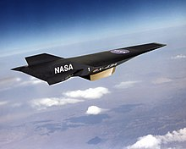

**Fig 1.** NASA X43 with the scramjet engine attached to the underside

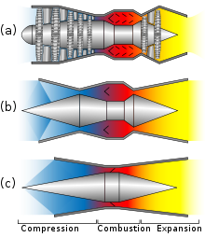

**Fig 2**. The compression, combustion, and expansion regions of: (a) turbojet, (b) ramjet, and (c) scramjet engines.

Operation of the typical scramjet (see **Fig 3**.): the supersonic airflow enters the scramjet inlet and is compressed, it then enters the supersonic combustion chamber where the supersonic airflow is mixed with fuel, it then enters the diverging nozzle before which the gases ignite and combust in the combustor region just before the nozzle where the combusted gases are expanded into atmospheric air.

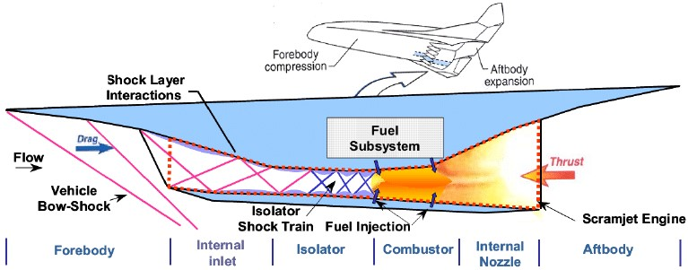

**Fig 3.** Typical scramjet components and operation

the major technical issues regarding the scramjet operation are the mixing of the high-speed air with the fuel and the maintaining of the stable combustion. Some methods employed to improve mixing include cavity, struts, aerodynamic ramps, pylons, injectors injecting fuels transversely to the flow etc, hydrogen has proven to be a good fuel choice for scramjet combustors. Amongst the above mentioned cavity has been selected due to its efficient mixing.

**1.2 Aim of computational investigation:**

We select the base Axisymmetric cavity design and begin our modelling by introducing injectors, we set 4 equi-spaced injectors at 0°,90°,180°&270° along the circumference, we evaluate the performance for 4 cases of the injector orientations, with different angles and positions of injections, the most optimum is selected and fixed, further modifications are carried out in the double ramp angles located at the aft section of the cavity, the primary ramp angles are varied through 30°, 45°& 60°, and the secondary angles are varied through 15°, 30°, & 45°. Further details regarding the injector cases and ramp variation are explained in detail in the following chapters.

**1.3 Research Objectives:**

• By analysing the various injector cases we desire to deduce the injector design which gives better fuel penetration and mixing hence resulting in a better combustion.

• By analysing the various ramp angle combinations we deduce the best combination which ensures better mixing and combustion whilst not giving a high pressure fluctuation.

• We carry out the turbulence modelling of combustion using the two equation SST k-omega model with the eddy dissipation model to model the combustion.

**CHAPTER 2**

**LITERATURE REVIEW**

**2.1 Characteristics of cavity flowfield:**

Cavity type flows generally fall into two categories, open-type cavity (**Fig 4.)** & closed-type cavity (**Fig 5**.) The shear layer forming over the cavity is the differentiating factor between the two types. In an open-type cavity the shear layer spans over the entire cavity and reattaches at some point downstream of the cavity. In a closed-type cavity the shear layer does not cover the full length of the cavity and ends up reattaching on the bottom wall before it reaches the end of the cavity.

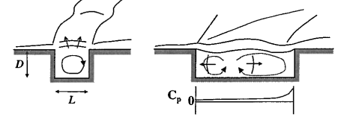

**Fig 4.** Open-type cavity

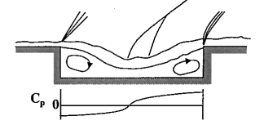

**Fig 5.** Closed-type cavity

The Length to Depth ratio (L/D) is a parameter used to describe the geometric characteristics of a cavity flame holder. Typically, an L/D ratio of less than 7 to 10 is classified as an open-type cavity and an L/D ratio of greater than 10 to 13 is classified as a closed-type cavity. As L/D is increased more and more, the drag force of the cavity will start to increase because the shear layer expands deeper into the cavity and exposes more of the aft wall to high pressures. In **Fig 5**. the pressure increase in the back wall and pressure decrease in the fore wall result in huge drag losses.

**2.2 Cavity oscillations:**

The unsteady motion of the shear layer over the cavity causes cavity oscillations which result in addition and removal of mass at the trailing edge of the cavity. This shear layer impinging on the rear wall will cause the flow to enter inside the cavity. Due to this the cavity pressure increases and an acoustic wave (compression wave) propagates towards the upstream and impacts the front wall (**Fig 6**). Because of the instabilities, the shear layer deflects upward and downward resulting in a shock/impingement event on the rear wall of the cavity.

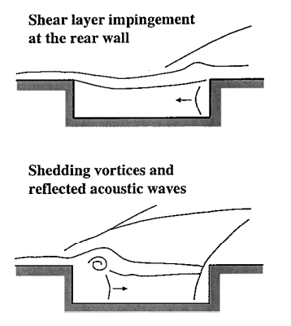

**Fig 6.** Typical longitudinal cavity oscillations caused by the impingement of the free shear layer on the rear wall

The shear layer fluctuations are the main cause of cavity oscillations, and if controlled it can improve the flow instabilities. Passive methods of control are simple and inexpensive. It includes placing some kind of a vortex generator upstream of the cavity like a strut or angling back the rear wall of the cavity (**Fig 7**). Both of these methods modify the shear layer in such a way that reattachment does not reflect pressure waves inside the cavity. Which in turn improve the stability of the flowfield. The angled back rear wall also eliminates any kind of disturbances caused by struts or fuel injection upstream of the cavity and it also enhances shear layer growth.

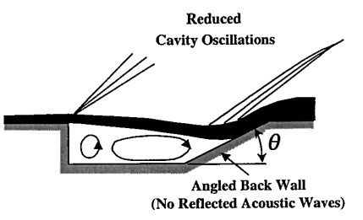

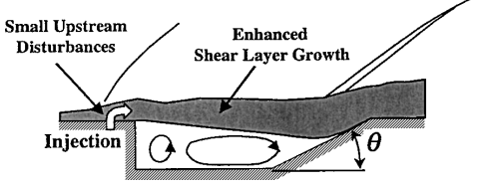

**Fig 7.** Effects of angled back wall cavity

Note: Active control methods, on the other hand, can continuously change to adapt to different flow conditions. Forcing of the shear layer can be accomplished by various mechanical, acoustical, or fluid injection methods.

**2.2 PRIOR WORK**

Relangi, N., Ingenito, A., & Jeyakumar, S. (2021) [1] published **The implication of injection locations in an axisymmetric cavity-based scramjet combustor.** This paper presents the effect of cavity-based injection in an axisymmetric supersonic combustor using numerical investigation.

Two transverse injection schemes where one is angled 30 degrees upstream of the cavity and another is normal to the bottom wall of the cavity, and two cavity fore wall injection schemes where one is angled 45 degrees and another which injects parallel to the flow field are studied. Both the transverse injections create a strong shock train in the cavity region which enhances complete combustion in the cavity region compared to the cavity fore wall injection schemes. From this paper the dimensions for our combustor’s geometry was taken, and we also got the idea of using K-omega SST turbulence model along with species transport for modelling the hydrogen-air mixture. We also used the same input parameters for the air and fuel to simulate combustion in our cavity-based combustor.

Jeyakumar, S., Assis, S. M., & Jayaraman, K. (2017) [2] published **Experimental study on the characteristics of axisymmetric cavity actuated supersonic flow.** In this paper, an attempt is made to understand the characteristics of supersonic flow past axisymmetric cavity, and a series of nonreacting experiments are carried out in a blow-down type supersonic flow facility. The effects of varying the aft wall angles is studied in detail in a nonreactive flow. They have concluded that reduction in the secondary aft wall angle below 45 degrees increases the static pressure in the aft section of the cavity. A similar trend was observed for the primary aft wall angle. This is because, when reducing the aft wall angles the effective length of the cavity is increased and the reattachment of shear layer at the aft wall of the cavity spans over the entire secondary aft wall of the cavity creating a compressive zone.

Relangi, N., Garimella, D., Jayaraman, K., Venkatesan, J., Jeyakumar, S., & Ingenito, A. (2020) [3] published **Computational Simulation of Axis Symmetric Aft Wall Angle Cavity in Supersonic Flow Field.** The same geometry of the axisymmetric cavity-based combustor from the previous experimental paper has been used to conduct a CFD cold-flow simulation with the same flow parameters. The experimental data collected from the previous paper is used to validate the results of this paper and it agrees reasonably well. Similar inference was formed, rectangular cavity provides a higher stagnation pressure loss than the aft wall angle cavity. Decrease in aft wall angle reduces the stagnation pressure loss indicating that a stable flow field is accomplished in the combustor.

Hsu, K. Y., Carter, C. D., Gruber, M. R., Barhorst, T., & Smith, S. (2010) [4] published a paper on **Experimental study of cavity-strut combustion in supersonic flow** which is a very well documented in-depth experimental investigation of cavity-based flameholders with strut fuel injectors.

This paper studies the flame propagation and ignition of fuel for three different strut geometries with fuel injectors mounted near the cavity leading edge. They have used planar laser-induced fluorescence of the OH radical to identify the flame zone around the cavity and strut-wake regions over a range of conditions. Shadowgraphy is employed to capture the flow features around the strut and cavity. Fuel is injected from two different injection schemes from the strut, as well as from the ports on the ramp of the cavity. Various combinations of fuelling schemes as well as the effect of additional air introduced into the cavity from the ramp were studied for all the three geometries of struts differing primarily in their aft body.

From the results it is concluded that, a) fuel injected upstream along the strut face burned more effectively. b) The addition of fuel directly in the wake of the strut created a fuel-rich zone that inhibited the effective burning of the strut fuel and disrupted the wake flow. c) Direct cavity air injection improved combustion in the cavity.

Gruber, M. R., Baurle, R. A., Mathur, T., & Hsu, K. Y. (2001) [5] published a paper on **Fundamental Studies of Cavity-Based Flameholder Concepts for Supersonic Combustors.** It is an experimental and computational investigations of the flow field associated with several cavity-based flameholders in a nonreacting supersonic flow, aimed at improving the fundamental understanding of cavity-based flameholders in supersonic flows. Their flow characteristics were visualized using schlieren and shadowgraph techniques.

Two values of L/D were studied with several offset ratios (OR) and aft ramp angles Ɵ. From the results it can be noted that, for arectangular cavity strong compression wave occurs at the separation corner of the cavity. The flowfield tends to be unstable due to cavity oscillations. Reductions in the aft ramp angle below 90 deg yield more stable, two-dimensional flowfields. The characteristics of the separation wave also change from compressive to expansive as the aft ramp angle is reduced. The cavity fore wall pressure steadily decreases with decreasing ramp angle. Reductions in ramp angle result in higher drag coefficients and shorter residence times within the cavity. However, the flowfield becomes increasingly stable and two-dimensional.

As the offset ratio (OR) is increased the separation wave is observed to be relatively strong and expansive in nature and the cavity fore wall experiences much lower pressure in these cases. The shear layer dips much further into the cavity. Changes in aft ramp angles had less influence in the overall performance in cases with increased offset ratio. As the aft wall angle is reduced, the drag increases due to higher pressures acting over a larger fraction of the aft wall area. This results from the flow expansion into the cavity.

Ben-Yakar, A., & Hanson, R. K. (2001) published **Cavity flame-holders for ignition and flame stabilization in scramjets: an overview,** a paper which describes research efforts in the scramjet community on cavity flameholders. They have summarized with very good illustrations about cavity flameholders and the characteristics of the flowfield in and around the cavity, and also summarized different flow field of open and closed cavities based on L/D ratio. They have also provided a summary on how to suppress or eliminate the cavity pressure waves that cause instabilities to the flowfield.

**CHAPTER 3**

**COMPUTATIONAL APPROACH**

**3.1 GEOMETRY**

**3.1.1 Axisymmetric Cavity geometry details for injector study:**

The axisymmetric cavity combustor **Fig 8**. [1] consists of an inlet with 26mm diameter and total length of 165mm which includes the isolator section which extends up to 35mm. The L/D ratio of the cavity is less than 10 so this is an open-type cavity. The aft wall of the cavity is divided into two angles of 30o and 15o.

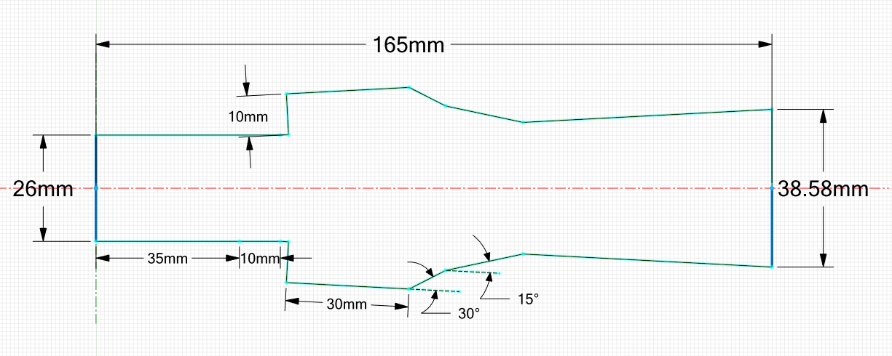

**Fig 8.** Detailed view of the combustor in 2D.

Four equi-spaced injectors of 1 mm diameter, placed at four different locations: Case 1 injection happens on the fore wall of the cavity at an angle of 45o. Similarly, Case 2 injection happens on the fore wall but parallel to the freestream. Case 3 is a transverse injection normal to the bottom wall of the cavity. Case 4 is also a transverse injection but at 30o angle in the upstream of the cavity.

**3.1.2 Computational domain**

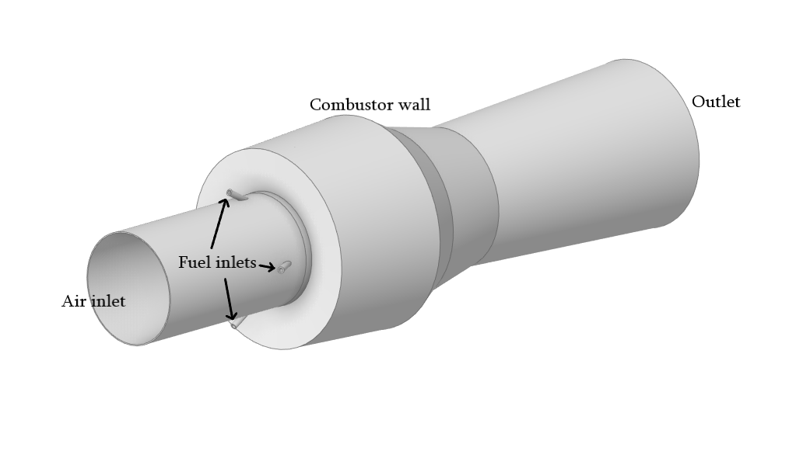

**Fig 9.** Schematic 3D view of the axisymmetric cavity combustor with case 4 injection location.

**Table 3.1.** Details of injection positioning

|  |  |  |
| --- | --- | --- |
|  | **Injection orientation** | **Location of injection** |
| **Case 1** | 45o | Fore wall of the cavity |
| **Case 2** | Parallel to the flow | Fore wall of the cavity |
| **Case 3** | 90o (Transverse) | Bottom wall of the cavity |
| **Case 4** | 30o (Transverse) | Upstream of the cavity |

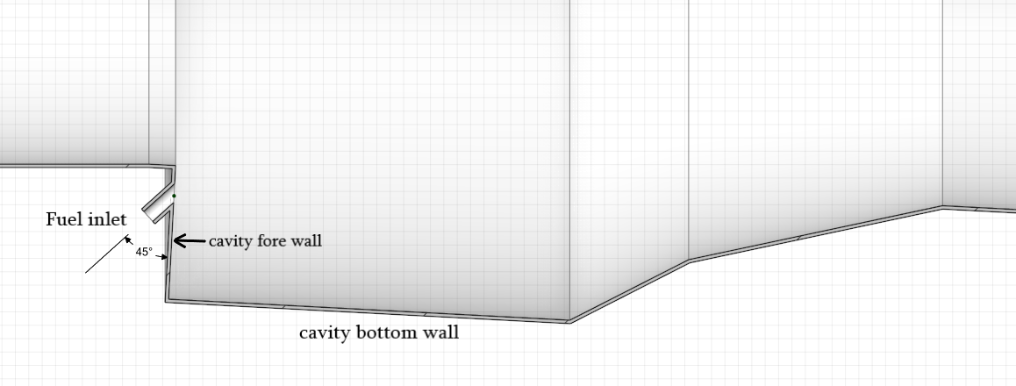

**Fig 10.** Case 1

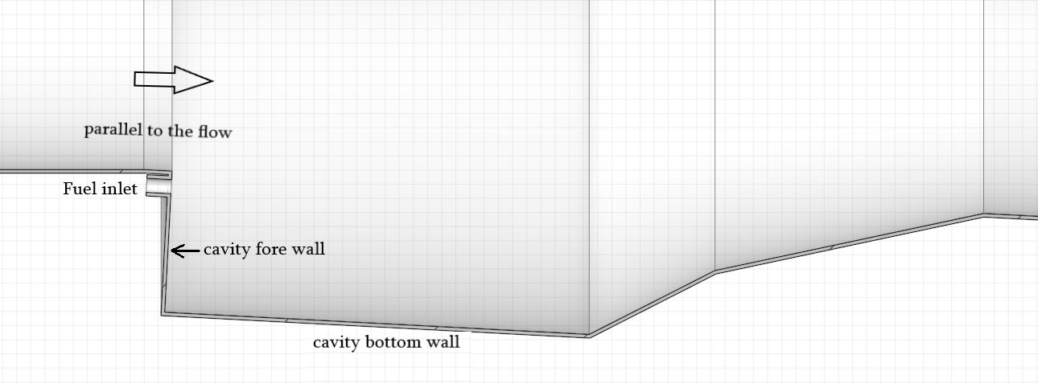

**Fig 11.** Case 2

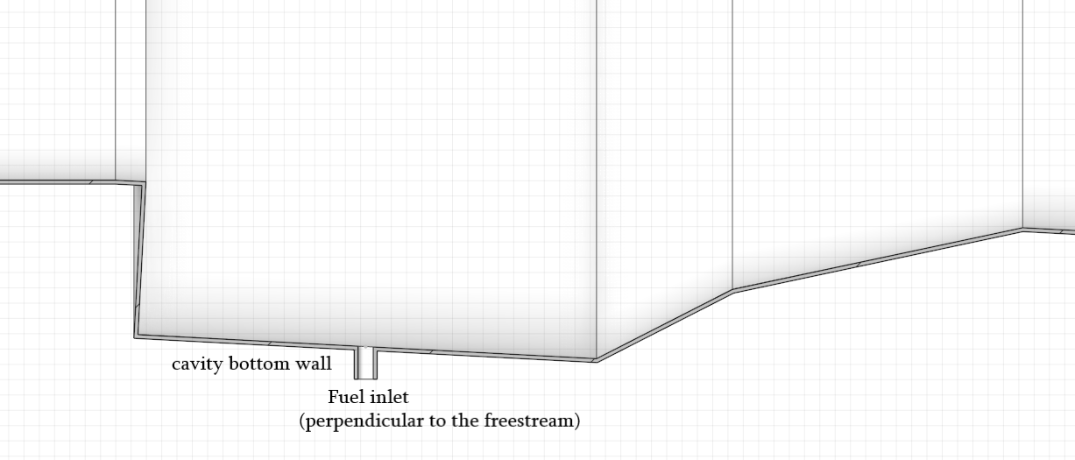

**Fig 12.** Case 3

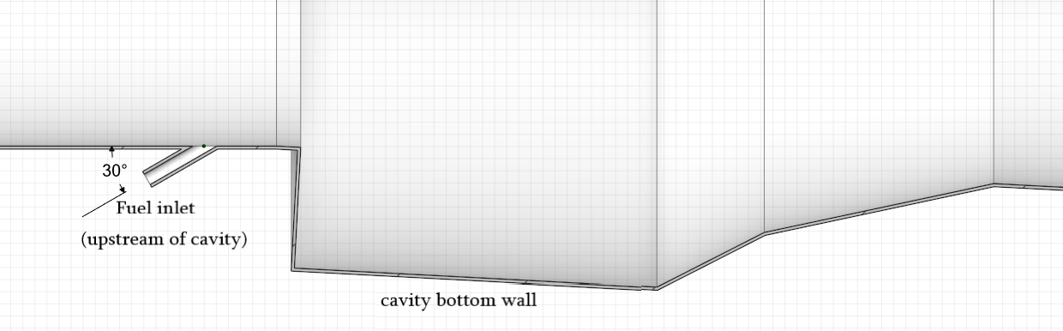

**Fig 13.** Case 4

**3.1.3 Geometry details for aft ramp angle variation study:**



**Fig 14.** Details of the cavity configuration.

The primary aft ramp angle (Ɵ1) starts from the bottom wall of the cavity and the secondary ramp angle (Ɵ2) starts from half the depth of the cavity.

The depth of the cavity is kept the same while the two aft ramp angles are being varied for the study. Case 4’s injector orientation and location is chosen for this study.

**Table 3.2.** Details of aft angle configurations.

|  |  |  |  |  |
| --- | --- | --- | --- | --- |
| **Angle configuration** | **Cavity L/D** | **Effective, Le/D** | **Primary angle, Ɵ1 (degree)** | **Secondary angle, Ɵ2 (degree)** |
| **60,45** | 3.2 | 3.7 | 60 | 45 |
| **60,30** | 3.2 | 4.1 | 60 | 30 |
| **60,15** | 3.2 | 5.1 | 60 | 16 |
| **45,45** | 3.4 | 3.9 | 45 | 45 |
| **45,30** | 3.4 | 4.3 | 45 | 30 |
| **45,15** | 3.4 | 5.3 | 45 | 15 |
| **30,45** | 3.8 | 4.3 | 30 | 45 |
| **30,30** | 3.8 | 4.7 | 30 | 30 |
| **30,15** | 3.8 | 5.7 | 30 | 15 |

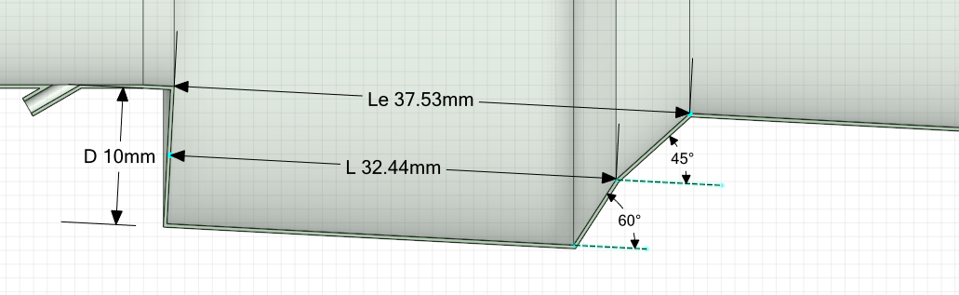

**a)**

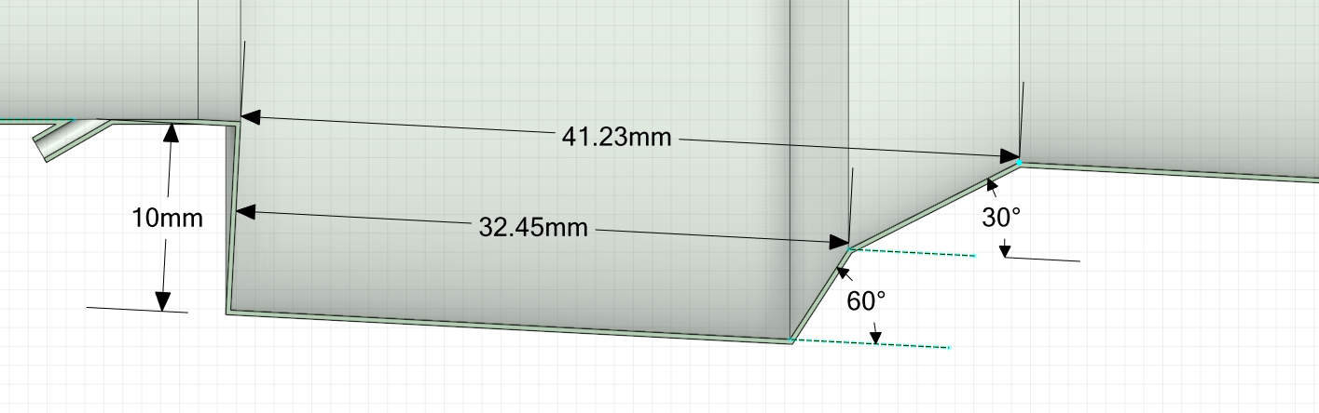

**b)**

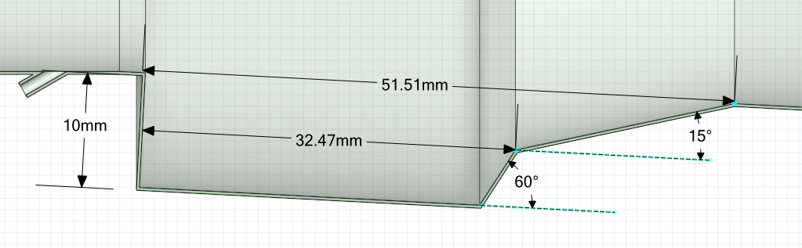

**c)**

**Fig 15.** Geometric details for ramp angle combinations of **a)** (60,45), **b)** (60,30), and **c)** (60,15)

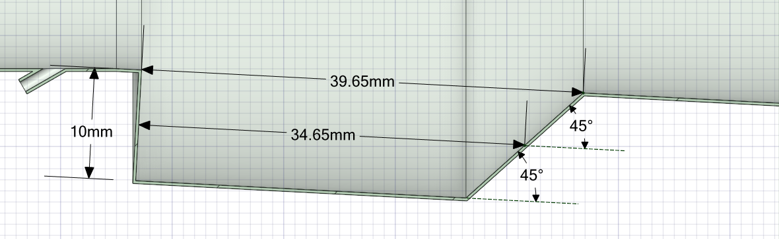

**a)**

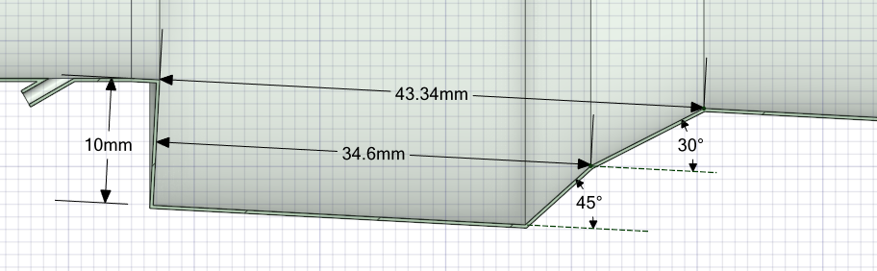

**b)**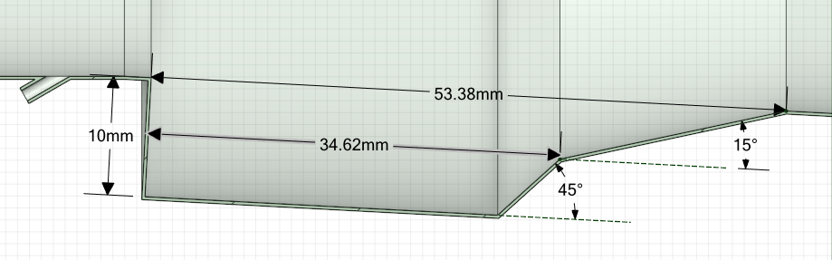

**c)**

**Fig 16.** Geometric details for ramp angle combinations of **a)** (45,45), **b)** (45,30), and **c)** (45,15)

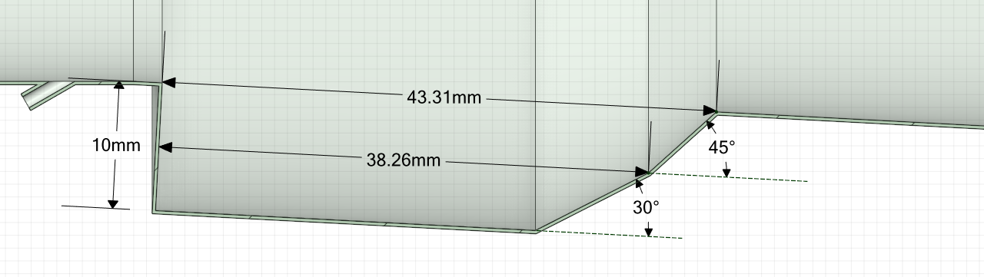

**a)**

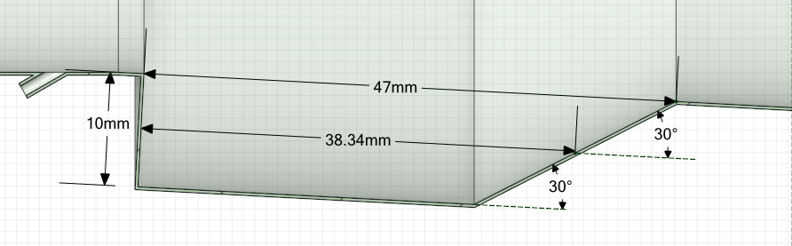

**b)**

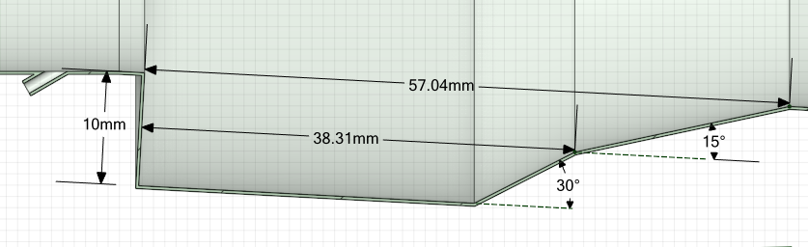

**c)**

**Fig 17.** Geometric details for ramp angle combinations of **a)** (30,45), **b)** (30,30), and **c)** (30,15)

**3.2 MESHING:**

A mesh is a tool that divides a geometry into many pockets which the CFD solver uses to generate control volumes.

Partial differential equations are solved by three computational approaches, namely:

1. FDM which discretizes the classical form of the PDE

2. FEM which discretizes the weak form of the PDE; and

3. FVM which discretizes the conservation form of the PDE.

FVM has the advantage of being mathematically simple and preferred for problems where quantity conservation is important as it discretizes the conservation form of the PDE.

In our case we use ANSYS, ANSYS Fluent mesh is one of two meshing tools included in the software Fluent mesh uses a Cell-Centered Green-Gauss Finite Volume Method.

**3.2.1 Terminology:**

* Cell - Control volume into which domain is divided.
* Cell Centre - Centre of a cell
* Face - Boundary of a cell
* Edge - Boundary of a face
* Node - Grid point.
* Zone - Grouping of nodes, faces, cells
* Domain - Group of node, face and cell zones.

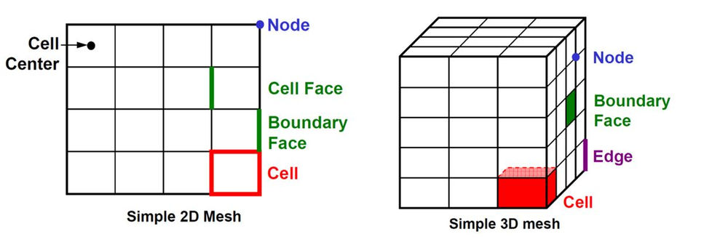

**Fig 18.** Cell Terminology

Critical knowledge needed before mesh generation include:

* Mesh type
* Resolution of mesh
* Capability of the computer system

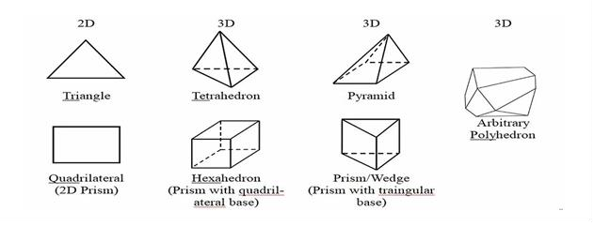

**Fig 19.** Cell volume types.

* Control volume shapes (**Fig 19**) are determined by the solver's capabilities.
* For **2D** flows structured-grid codes use *quadrilaterals* and unstructured-grid solvers use *triangles*.
* For **3D** flows structured-grid codes use *hexahedrons* and unstructured-grid solvers use *tetrahedro*n.
* **Ansys fluent** **meshing (3D)** uses a new kind of unstructured-grid called *arbitrary polyhedrons*.

**3.2.2 GRID TYPES**

There are 3 types of grids:

1. **Structured Grids:** Cartesian and Curvilinear **Fig 20**
2. **Block-structured Grids:** Matching **Fig 21**, Non-matching **Fig 21.** & Chimera **Fig 23.**
3. **Unstructured Grids**: Triangular (tetrahedral), Quadrilateral (hexahedral), Polygon (polyhedral) & Hybrid

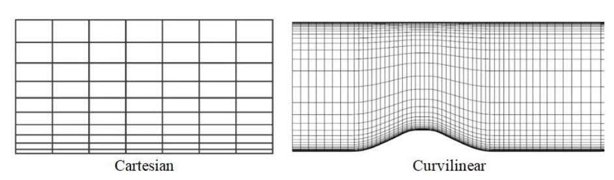

**Fig 20.** Cartesian and Curvilinear Grid

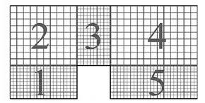

**Fig 21.** Non-matching grids.

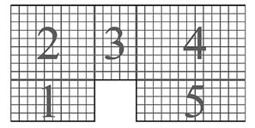

**Fig 22.** Matching grid.

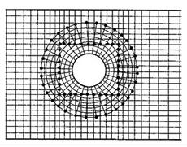

**Fig 23** Chimera

For 3D geometry, like our case we use the **unstructured grids**

Unstructured meshes allow for fully arbitrary geometries to be accommodated. However, this versatility comes with considerable costs, both in terms of connectivity data structures and solution algorithms. Grid generators and plotting routines for such meshes are also extremely difficult to create.

**Quadrilateral/hexahedral and Trihedral/Tetrahedral meshes:**

* For *flow-aligned problems,* quadrilateral/hexagonal meshes can provide higher quality solutions with fewer cells/nodes than a comparable Trihedral/Tetrahedral mesh.
* Quad/hex meshes show reduced numerical diffusion when the mesh is aligned with the flow. It does require more effort to generate a quad/hex mesh.
* For *complex geometries*, it would be impractical to generate a structured (flow-aligned) hex mesh. You can save meshing effort by using a Tri/Tet mesh or hybrid mesh which are quicker to generate.

**Hybrid meshes** typically combine Tri/Tet elements with other elements in selected regions.

In our current study, unstructured grid is created with polyhedral cells using **Ansys mosaic meshing**. Mosaic mesh is a Ansys Fluent meshing technology for computational fluid dynamic simulations. It accelerates the meshing process with a reduced face count, higher quality cells and efficient parallel scalability. Mosaic meshing technology enables polyhedral connections between disparate mesh types. The polyhedral mesh is derived directly from the tetrahedral mesh by forming polygons around each node in the tetrahedral mesh.

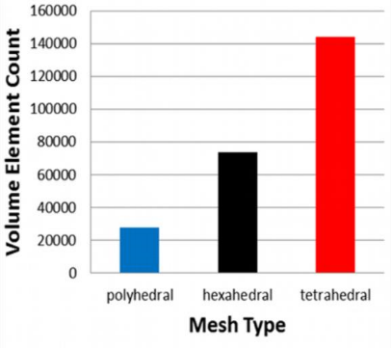 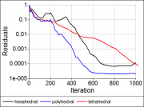 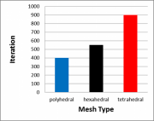

**Fig 24.** Influence of element type on element count and computational cost.

Generally, accuracy and computational cost are determined by the number of cells; that is, more cells indicate high accuracy and cost, but this is not always true. Accurate and reliable solutions can also be obtained by the appropriately selecting the element types and grid generation methodology, such as structured and unstructured grid formation.

Currently polyhedral elements are preferred over tetrahedral elements, as researchers have *(Peri,2004; Garimella et al.,2014)***[10]** concluded that polyhedral elements can overcome the discrepancies associated with tetrahedral elements using fewer elements and the same level of automatic mesh generation ability. Furthermore, they reported that polyhedral elements are surrounded by more elements than tetrahedral element are, which increase the accuracy of approximate solutions.

*[Through literature survey it is found that polyhedral elements performed more favourably than tetrahedral elements. However, the results of hexahedral element were closer to those of the experiment.]*

**3.3 PRE-MESHING SETUP**



**Fig 25.** Naming of boundary surfaces

After designing the model in Spaceclaim the naming of the boundary surfaces is done. This will be useful when assigning the type of boundary, and also be useful to give an option of local sizing while generating the mesh. There are two kinds of inlet in our specific geometry. One air inlet and four fuel inlets. And one outlet at the back of the combustor. Wall boundary is chosen for the inner wall surfaces of the combustor and the inner wall surfaces of the injectors.

**3.4 GENERATING MESH:**

**3.4.1 Process of mesh generation:**

The generation of mesh is carried out in fluent meshing tool within Ansys Workbench. A mosaic mesh was developed using poly-hex core cells. The boundary effects are captured by poly prism cells near the walls, while ploy-hex core cells is generated throughout the rest of the flow field. The process of generating the mesh using fluent meshing is as follows: -

1. Watertight geometry is selected in the workflow, for units ‘mm’ is chosen in our case. Then the geometry file is imported.
2. The next step is adding local sizing to give a more detailed mesh in certain areas on interest. In our geometry the injector is relatively small in size. So a body was designed while modelling the geometry to be assigned as ‘body of influence’ in this step. A finer mesh with maximum size of 0.1mm is assigned to that body of influence within the injectors (four).
3. A surface mesh is created in this step with minimum and maximum element size. A minimum size of 1mm and a maximum size of 2mm is given. The surfaces of the fuel path region will be meshed in smaller sizes according to the local sizing given for the body of influence in the previous step.
4. Our geometry consists of only solid regions with no voids so that option is chosen to describe our geometry in this step. We then proceed to cap the openings (air inlet, four fuel inlets and outlet) to extract a fluid volume out of our solid watertight geometry. We then assign the right boundary type for each the boundary surface.

**Table 3.3. Assigned boundary types**

|  |  |
| --- | --- |
| **Boundary name** | **Boundary type** |
| Air inlet | Pressure inlet |
| Fuel inlet | Pressure inlet |
| Outlet | Pressure outlet |
| Combustor & injector walls | Wall |

1. Boundary layers are added to capture near wall effects. 15 layers of boundary are added for the combustor wall and 5 layers for the injector wall, with wall spacing of 0.01mm.
2. A poly-hex core mesh is generated with a minimum and maximum cell size of 0.001mm and 1.024mm respectively with a total cell count of 377,704 (medium grid).

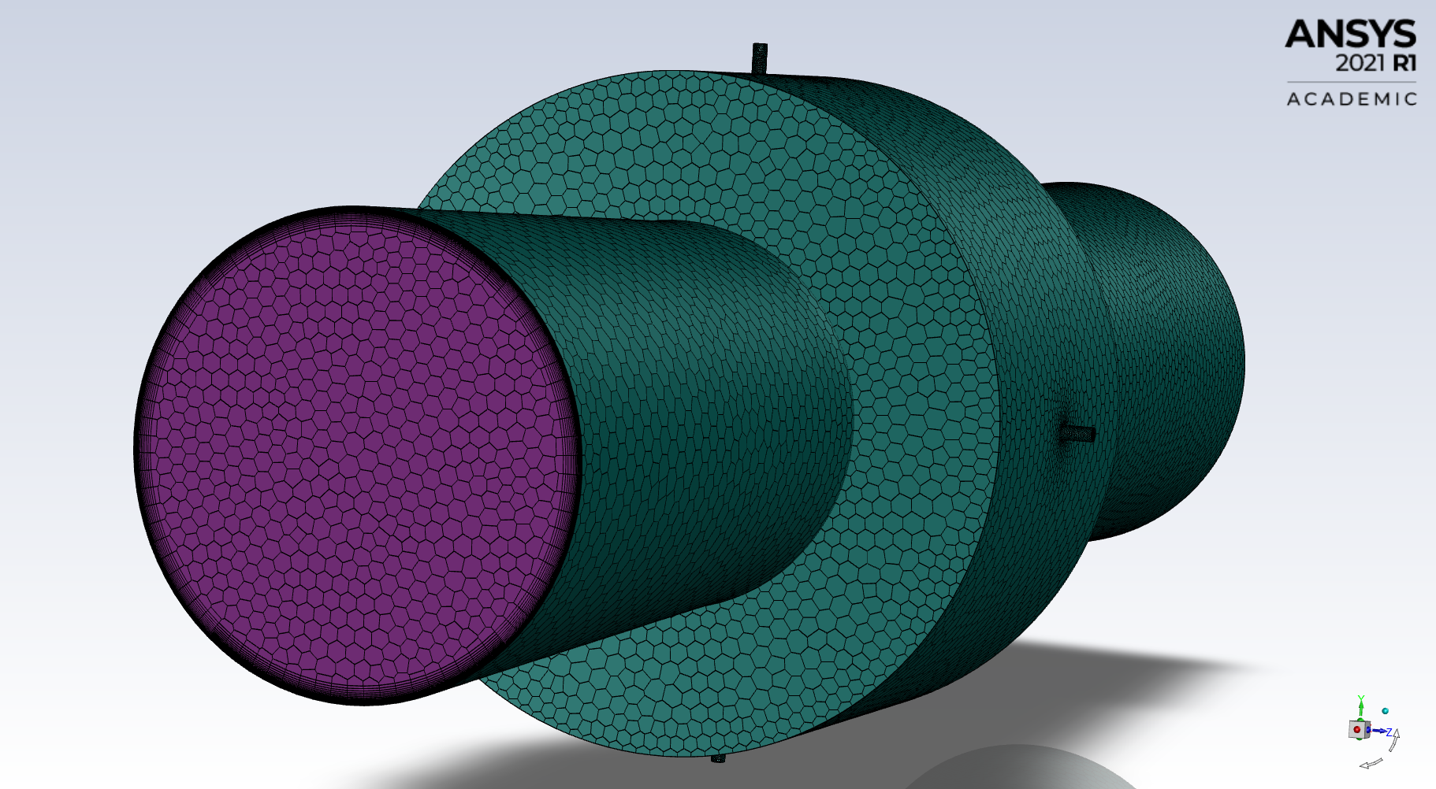

**Fig 26.** 3D view of the combustor with its surface mesh

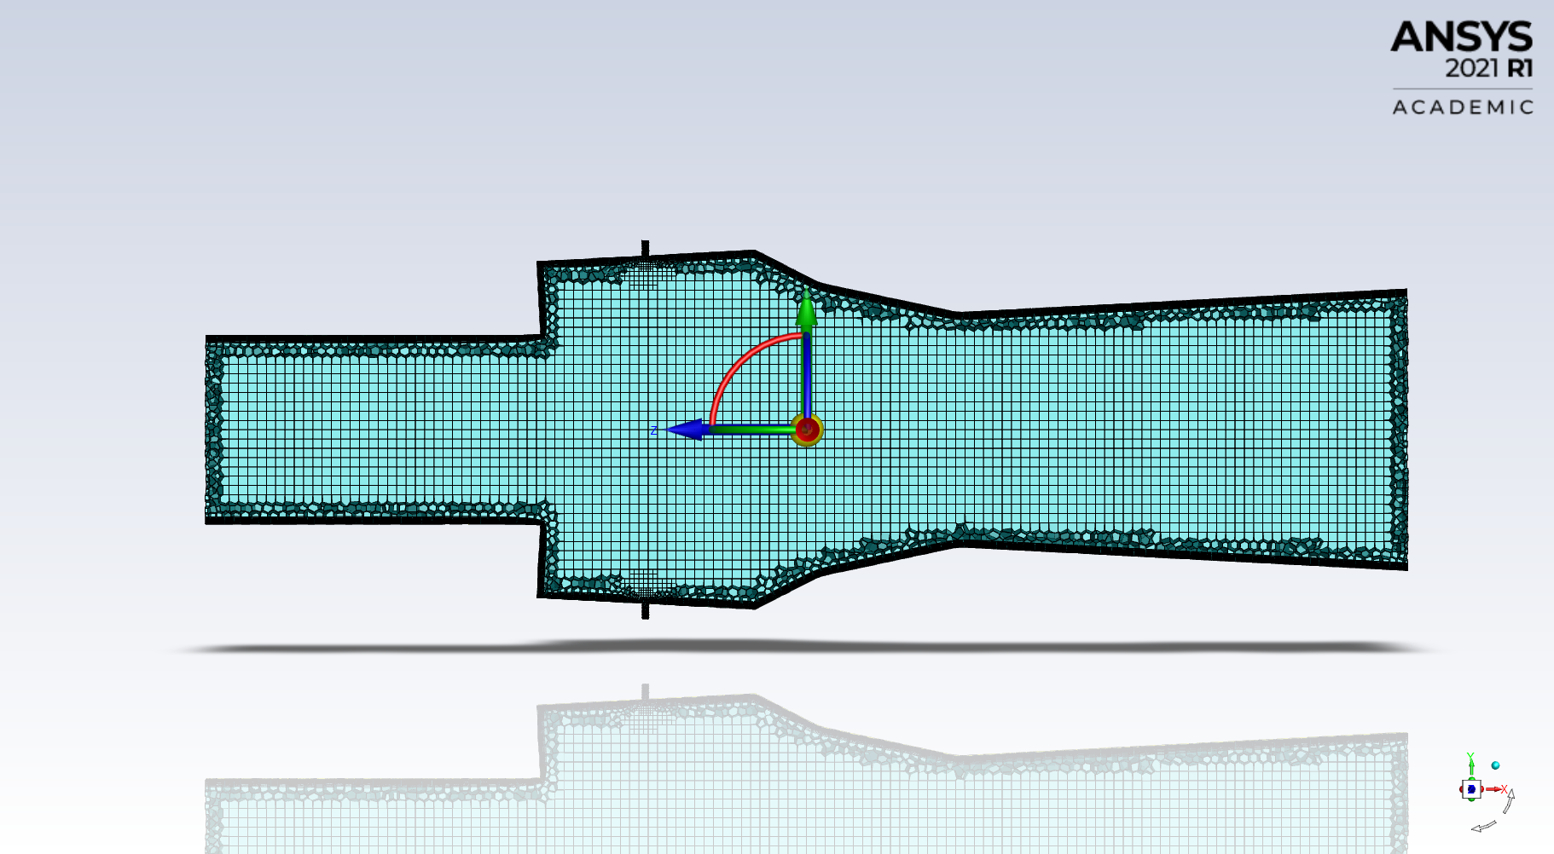

**Fig 27.** Cross section cut view of the unstructured mesh

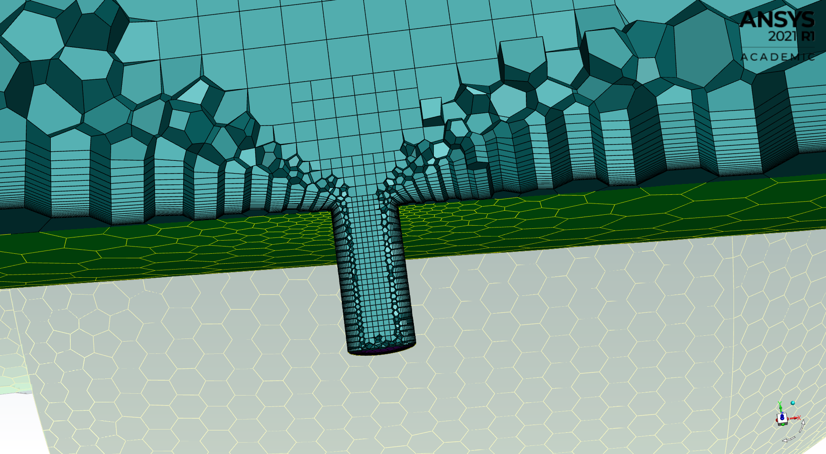

**Fig 28.** Zoomed in view of the mesh near the injector.

**3.4.2 Grid independence study:**

Three grid sizes were taken for our grid study. A coarse grid of 260,000, a medium grid of 377,704 and a fine grid of 491,932 cells were compared to choose the grid that would be optimum for our simulation with consideration of our computational resources. Wall static pressure distribution is taken as the measure for our comparison. Results for all the grid sizes proved to show a good level of accuracy. Medium and fine grids were found to be 99% in agreement. And we chose to go with the medium grid considering the computational time and cost that was required.

**Fig 29.** Wall static pressure distribution for the three gird sizes.

**3.5 SOLUTION SETUP**

A 3D RANS equation k-omega SST turbulence model is used to predict the flow field. The SST k-omega turbulence model is a two-equation eddy-viscosity model which is a hybrid model combining k-omega and k-epsilon. The k-omega model is well suited for simulating flow in the viscous sub-layer. The k-epsilon model is ideal for predicting flow behaviour in regions away from the wall. The SST k-omega model employs k-omega for predicting flows near wall and k-epsilon model in the freestream.

Species transport is used for modelling combustion. The eddy-dissipation model has been implemented to solve the turbulence-chemistry interactions. The mixture material for our simulation is hydrogen-air.

The flow is compressible and obeys the laws of an ideal gas. A density-based, implicit, second-order upwind scheme with an advection upstream splitting methos (AUSM) flux vector [1] solves the governing equations.

**3.6 GOVERNING EQUATIONS:**

Continuity 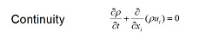 …… (1)

Momentum 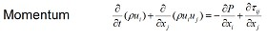 …… (2)

Energy 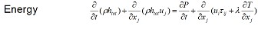…… (3)

The above the 3 elemental governing equations in gas dynamics

Where, 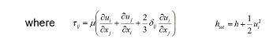…… (4)

The above is the shear stress equation.

**SST k-omega governing equations**

Turbulence kinetic energy;

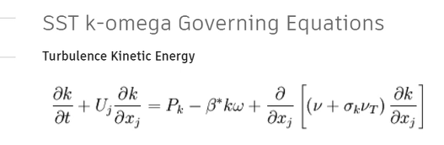 …… (5)

Specific dissipation rate;

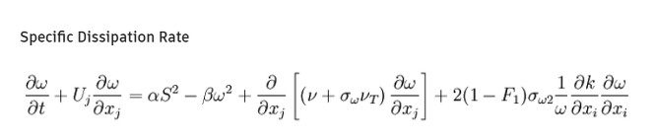 …… (6)

The above are the governing equations for the SST k-omega turbulence model.

Species transport equation;

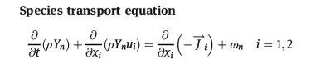 …… (7)

The above equation is used for combustion modelling.

**3.7 BOUNDARY CONDITIONS:**

**Table 3.4. Boundary conditions**

|  |  |  |
| --- | --- | --- |
| **Boundary name** | **Boundary condition** | **Input variable** |
| Air inlet | Pressure inlet | Stagnation pressure: 480,000Pa  Static pressure: 83,000Pa  Total temperature: 540k  Yo2: 0.232  Yh2: 0  Yh2o: 0.032 |
| Fuel inlet | Pressure inlet | Stagnation pressure: 700,000Pa  Static pressure: 370,000Pa  Total temperature: 300k  Yo2: 0  Yh2: 1  Yh2o: 0 |
| Combustor and injector walls | Wall | Wall type: No slip  Wall motion: Stationary |
| Outlet | Pressure outlet | No input needed |

**CHAPTER 4**

**POST-PROCESSING AND RESULTS**

**4.1 Flow visualization:**

We make use of the colour contours of various parameters to visualize the flow, the condition of the set flow parameters in the specific locations is indicated by means of colours, upon reference from the colour scale provided, one can point out the nature and change of the parameter at the said point/region. Regions of flow deceleration and combustion can be identified as well as identification of phenomena such as oblique shocks, shocks trains, Mach disc and expansion waves are achieved by the help of these contours. The propagation and combustion of fuel from the point of injection can also be tracked by the help of certain contours of mass fraction. These contours also help us in identifying instabilities and with the additional help of the plots help in filtering out faulty designs.

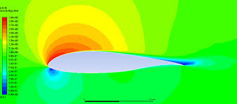

**Fig 30.** A velocity magnitude contour of an aerofoil. (example)

**4.2 Injector position study:**

**4.2.1 Mach number:**

For injector optimization phase we begin our computation, inlet Mach number is 1.8 and the injectors inject the hydrogen fuel at Mach 1. The combustion then occurs and the contours are generated after the solution is complete and the residuals are within acceptable levels of convergence. The contours thus obtained for the 4 cases are given below.

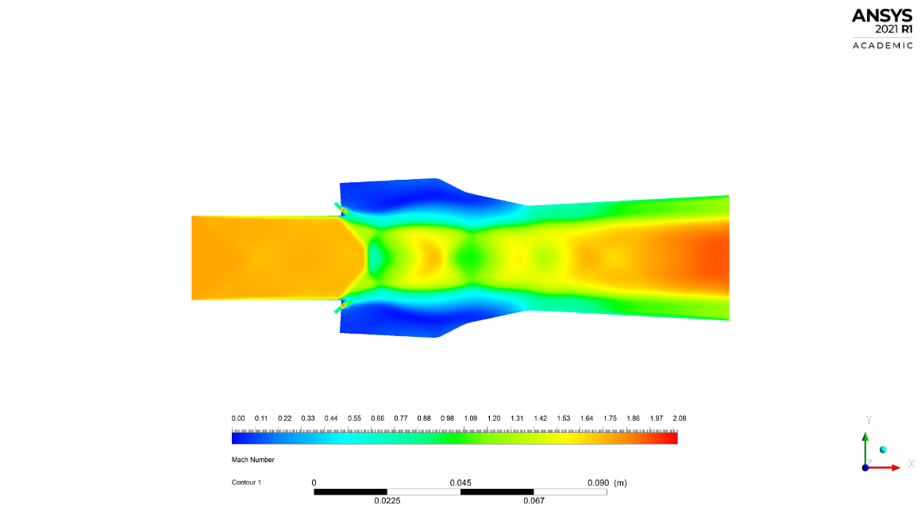 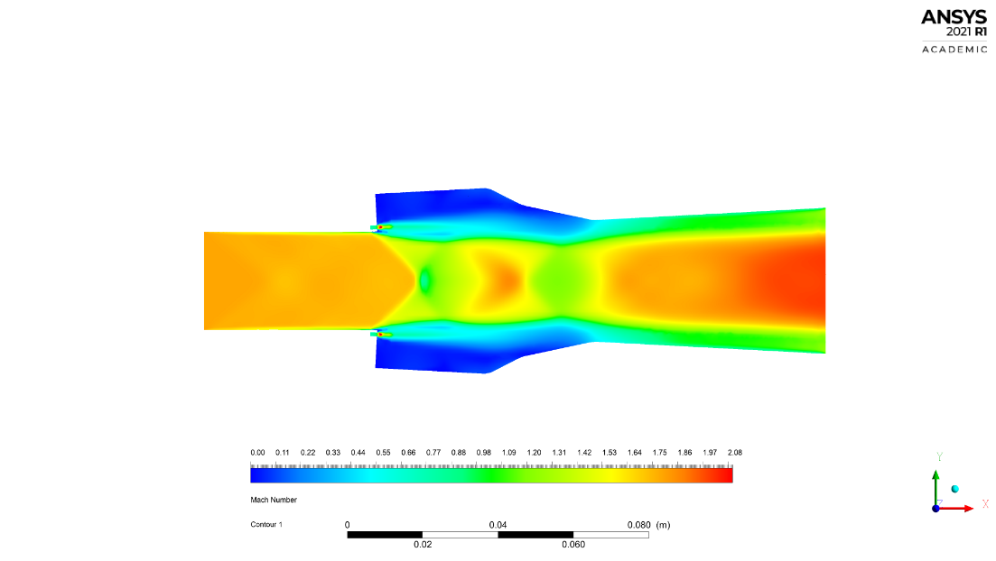

a) Case 1 b) Case 2

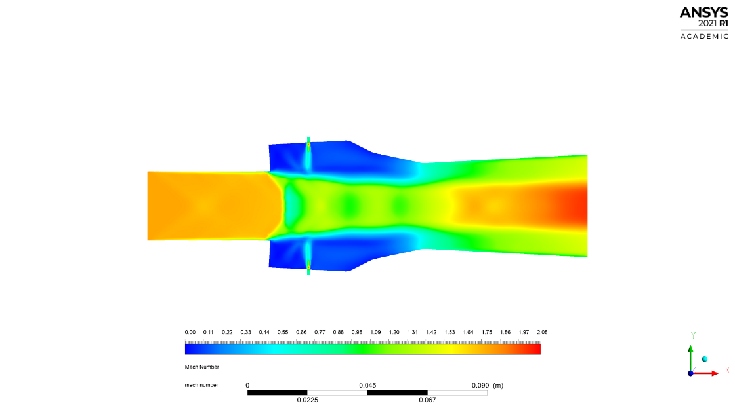 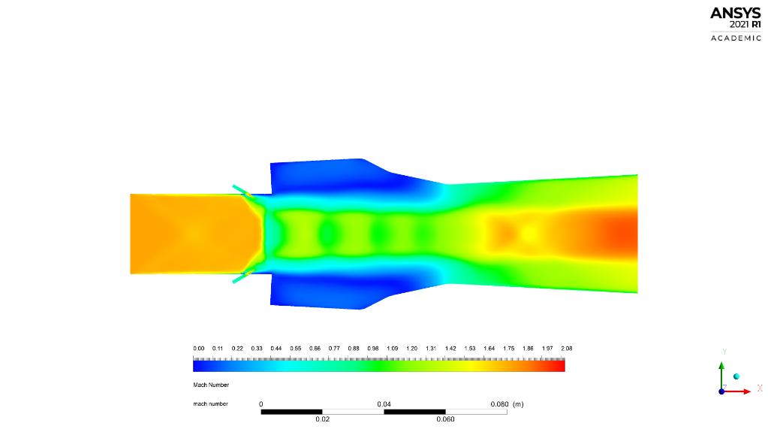

c) Case 3 d) Case 4

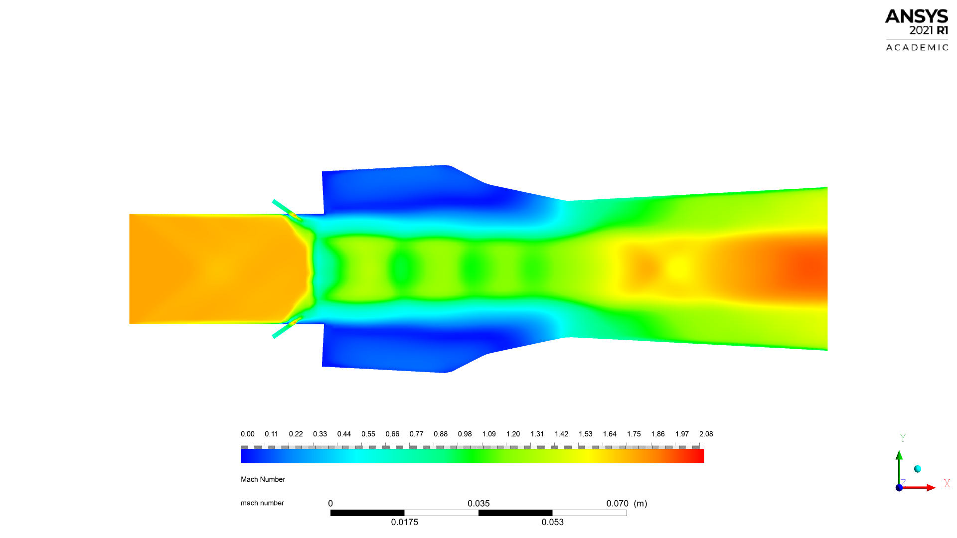

**Fig 31.** Mach number contour for the four injection schemes.

From the obtained contours we can deduce some amount of instability starting from the cavity region in case 1 and 2, 2 being worser. It is however noted that cases 3 and 4 fare far better in terms of stability especially starting from the cavity region, case 4 being far better this is seen visually with the presence of uniform shock trains present.

**Fig 32.** Mach number plot for the four injection schemes along the central axis of the combustor.

**4.2.2 H2 mass fraction:**

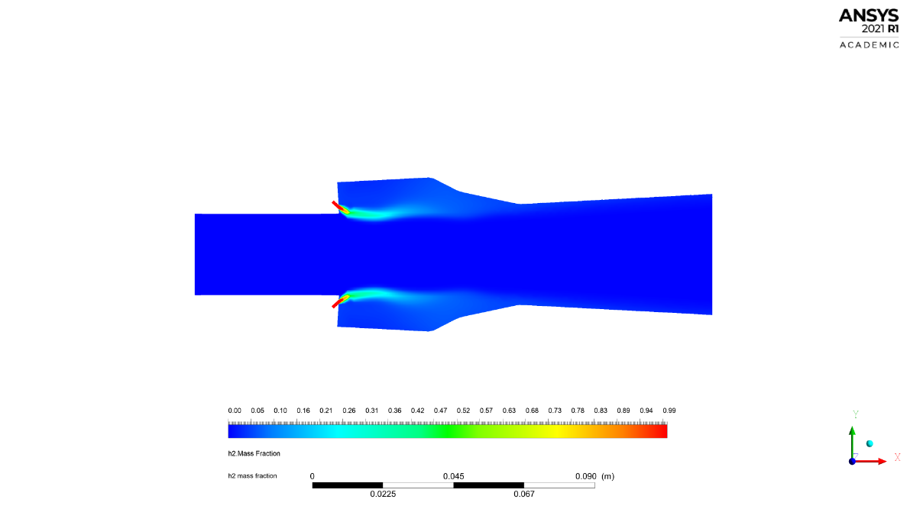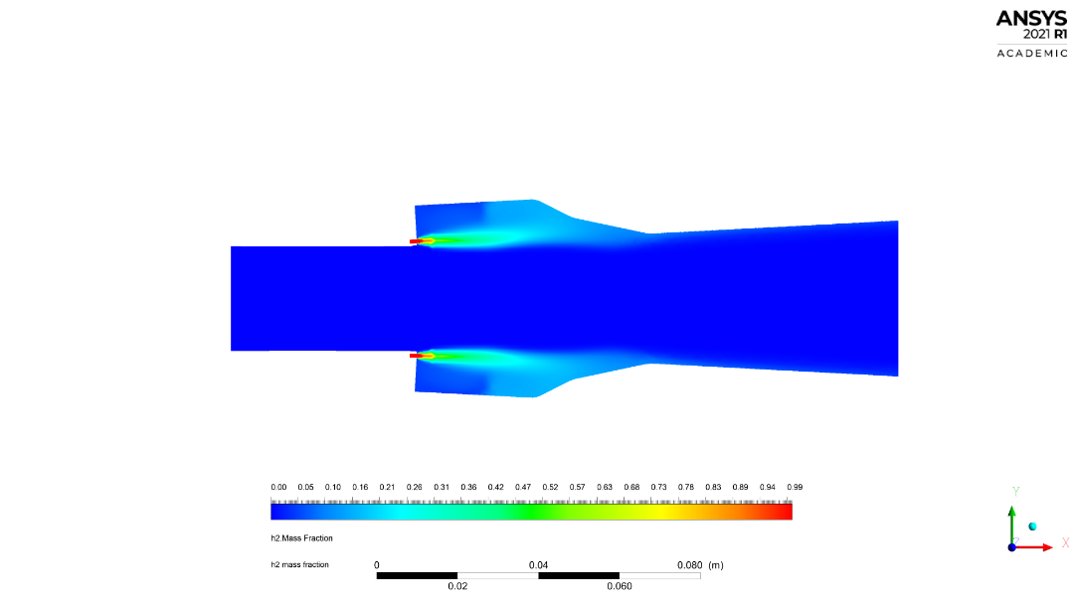

a) Case 1 b) Case 2

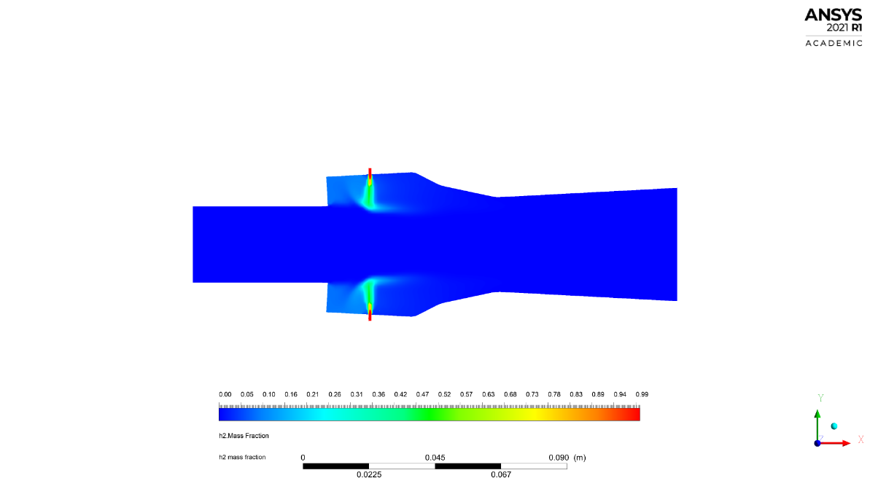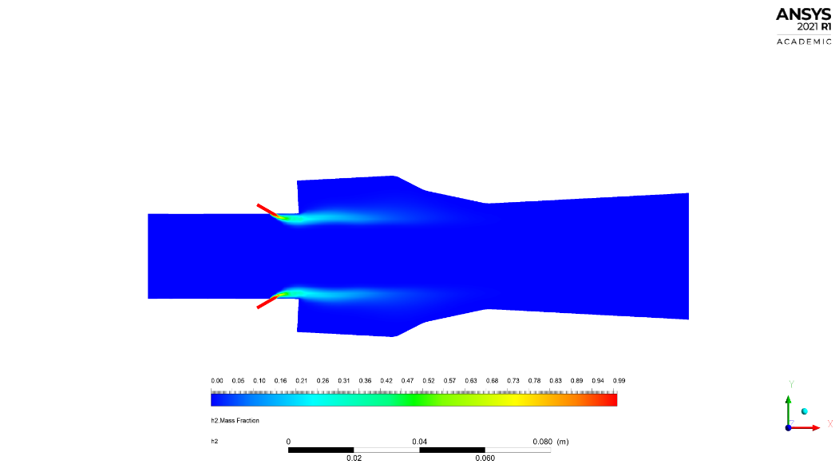

c) Case 3 d) Case 4

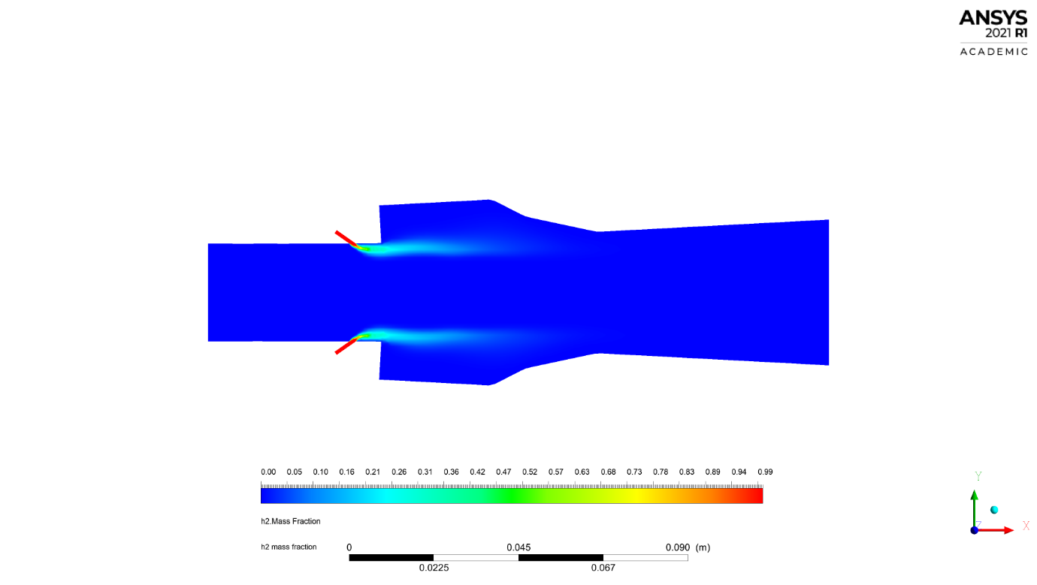

**Fig 33.** h2 mass fraction contours for the four injection schemes.

We are able to track the fuel content downstream from the injection starting from the point of injection, this parameter enables us to deduce effectively on how efficiently the fuel is mixed and more importantly how well is it combusted and changes form hence disappearing from the plot quicker leaving as less unburnt residue as possible. Clearly case 4 leaves the least residue behind and hence is the better option.

**4.2.3 H2o mass fraction:**

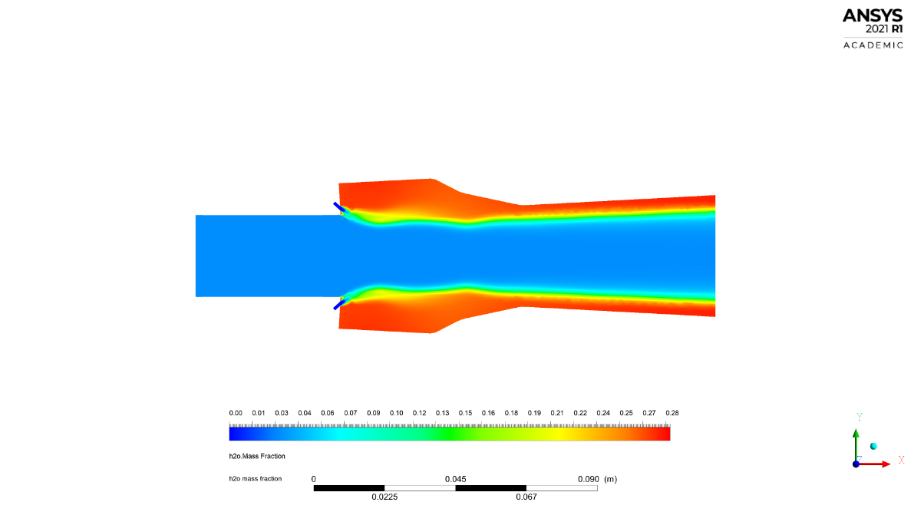 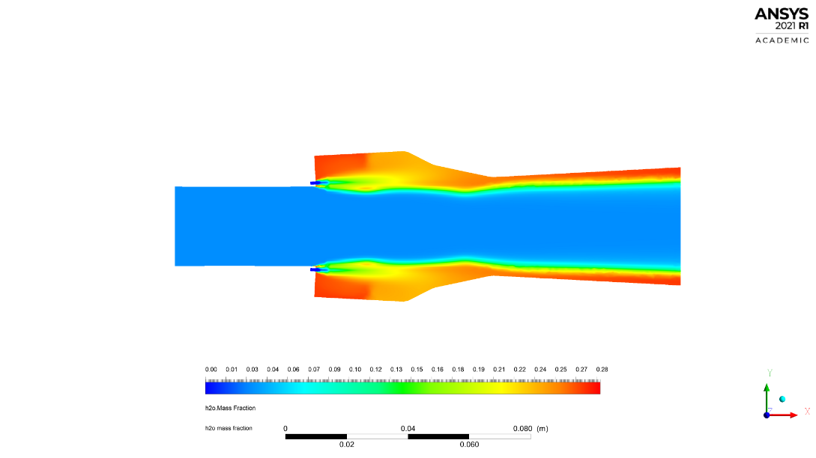

a) Case 1 b) Case 2

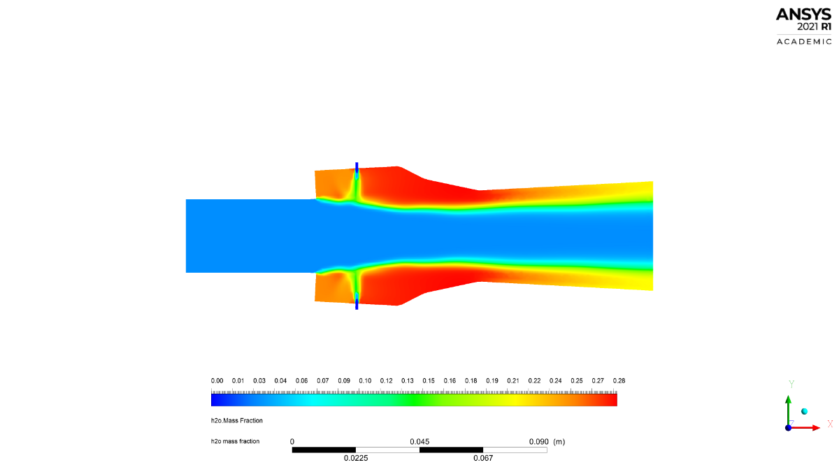 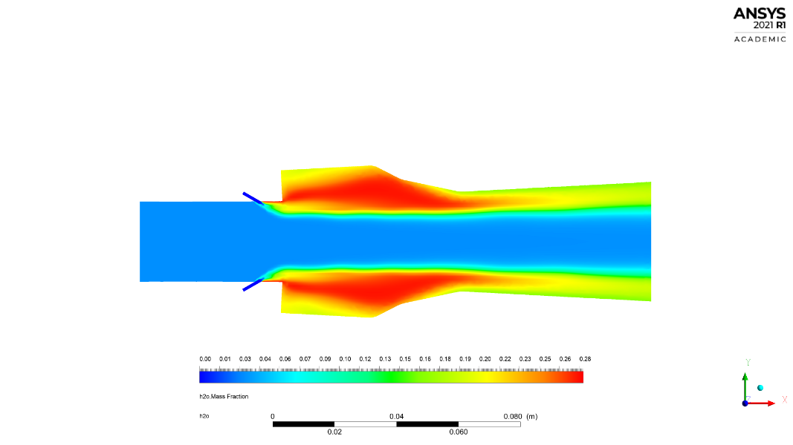

c) Case 3 d) Case 4

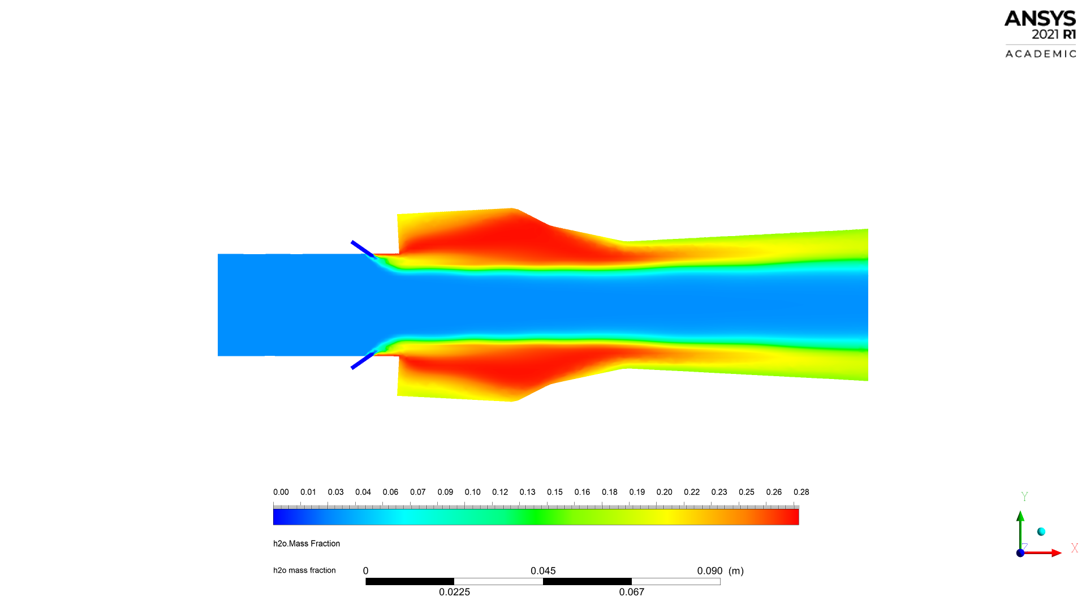

**Fig 34.** h2o mass fraction contour for the four injection schemes

We are now able to track the generation of H2O or water which is the by-product of combustion of hydrogen in air, the amount of H2O generated is directly proportional to the completeness of the combustion. A widely distributed H2O contour indicates the incompleteness of the combustion as hydrogen continues to travel with air downstream whilst combusting. However, on viewing of case 4 it is evident that the combustion is focussed in and around the cavity area, though the presence of water is noticed downstream it continually diminished pointing out to the continually diminishing combustion.

**4.2.4 Temperature:**

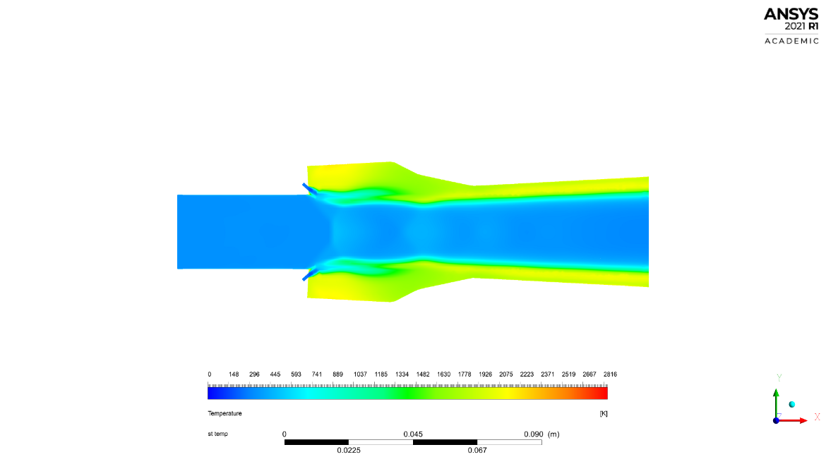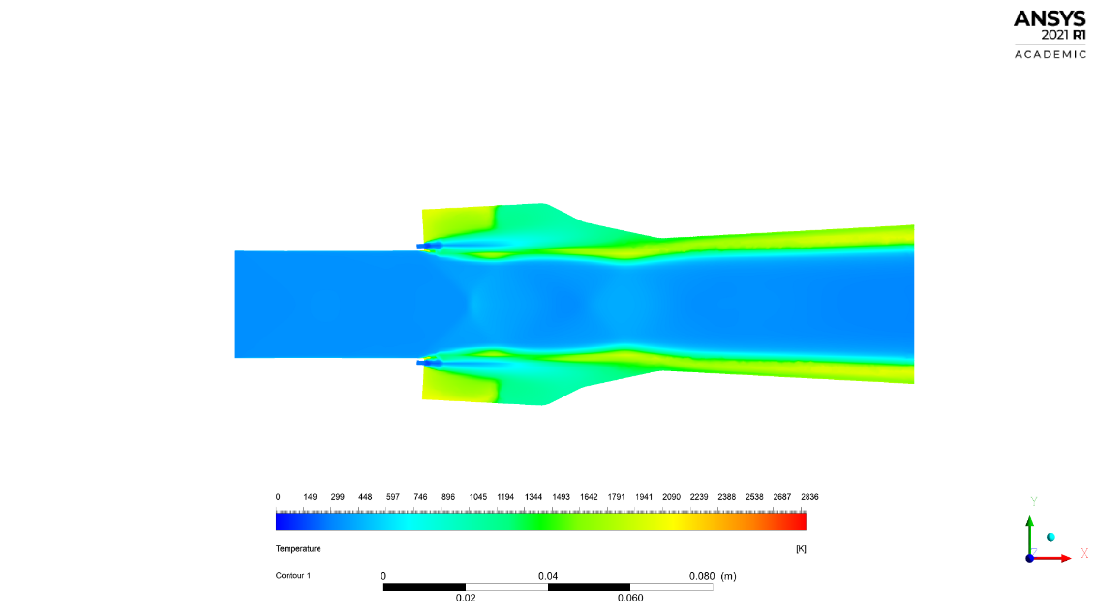

a) Case 1 b) Case 2

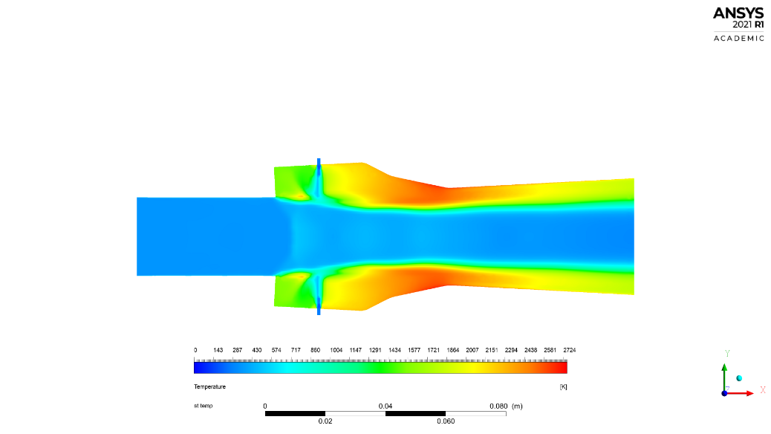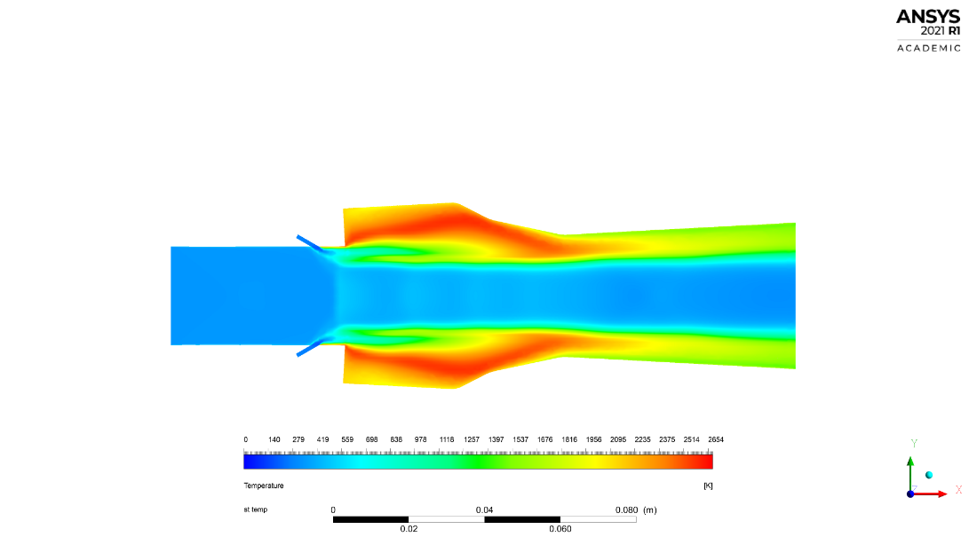

c) Case 3 **d)** Case 4



**Fig 35.** Temperature contour for the four injection schemes.

The temperature is instrumental in determining the quality of combustion or even to establish if the combustion is happening at all. Higher temperatures reached indicate a more complete combustion. Upon noticing of the contours it is very evident that case 4 is clearly superior compared to other cases reaching to about 2600K.

**Fig 36.** Wall static temperature comparison for the four injections.

**4.2.5 Wall static pressure distribution:**

**Fig 37.** Wall static pressure plot comparison for the four injectors.

It is evident from the wall static pressure case 4 is the clear choice reaching a higher ceiling and blanketing a higher distance. This is because the combustion occurs mainly near the walls, starting from the cavity.

From our computational analysis case 4 injector assembly is shown to be superior to other injector assemblies, along with case 3 which is far better than case 1 and 2 the general scheme of the case 1 and 2 injectors are omitted and the scheme of case 3 and 4 are adopted, the interference thus obtained is that injection of fuel in any angle transverse to the main airflow results in a better combustion, this occurs due to better penetration of the air flow and hence a better mixing. This, along with the scheme of the case 4 assembly which is an upstream injection is adopted for further optimization of the cavity double ramp angles.

**4.3 Aft ramp angle variation study:**

**Table 4.1.** Details of aft angle configurations.

|  |  |  |  |  |
| --- | --- | --- | --- | --- |
| **Angle configuration** | **Cavity L/D** | **Effective, Le/D** | **Primary angle, Ɵ1 (degree)** | **Secondary angle, Ɵ2 (degree)** |
| **case a1: 60,45** | 3.2 | 3.7 | 60 | 45 |
| **case a2: 60,30** | 3.2 | 4.1 | 60 | 30 |
| **case a3: 60,15** | 3.2 | 5.1 | 60 | 16 |
| **case b1: 45,45** | 3.4 | 3.9 | 45 | 45 |
| **case b2: 45,30** | 3.4 | 4.3 | 45 | 30 |
| **case b3: 45,15** | 3.4 | 5.3 | 45 | 15 |
| **case c1: 30,45** | 3.8 | 4.3 | 30 | 45 |
| **case c2: 30,30** | 3.8 | 4.7 | 30 | 30 |
| **case c3: 30,15** | 3.8 | 5.7 | 30 | 15 |

The ramp variation is done in three steps yielding nine combinations. The primary angle is fixed for a case and the secondary angle is varied three times as subdivisions to the same case and then change and fix the primary angle value and repeat the second ramp variation. Continue to do the same for the three specified primary angle positions.

* Case - a deals with all designs with a primary ramp angle of 60°.
* Case - b deals with all designs with a primary ramp angle of 45°.
* Case - c deals with all designs with a primary ramp angle of 30°.
* Subdivision 1 of all cases represents a secondary ramp angle of 45°.
* Subdivision 2 of all cases represents a secondary ramp angle of 30°.
* Subdivision 3 of all cases represents a secondary ramp angle of 15°.

**4.3.1 Mach number:**

**Case a: primary ramp angle fixed at 60**°

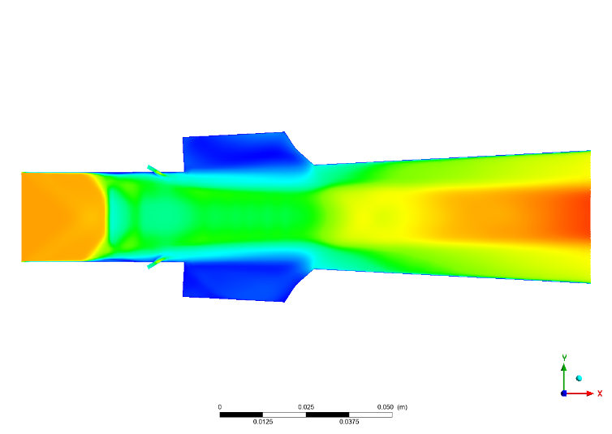

**a1)** (60,45)

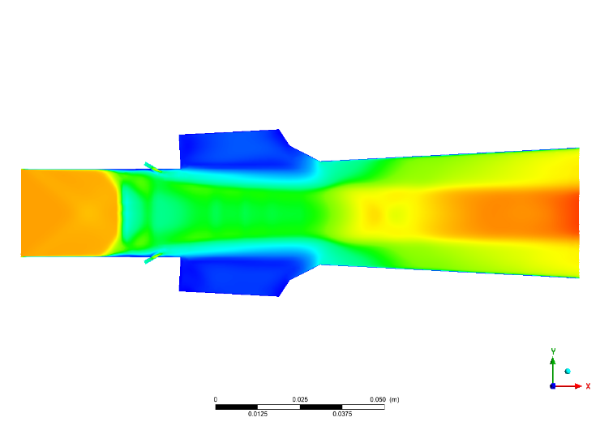

**a2)** (60,30)

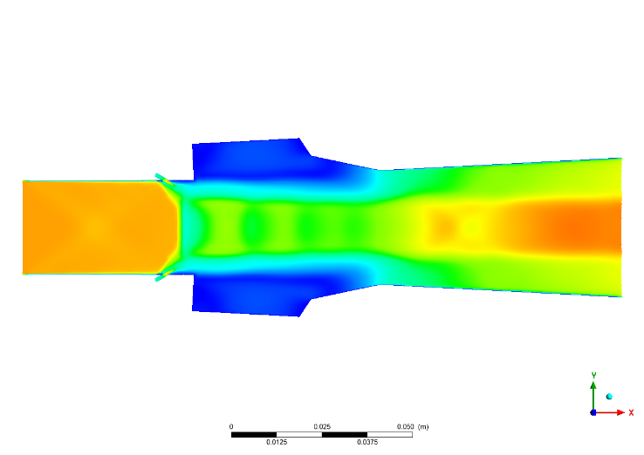

**a3)** (60,15)



**Fig 38.** Mach number contour comparison for different secondary ramp angles for a primary angle of 60°

It is evident from the above contours that flow in **case a3** is more stable due to the presence of the *shock train*, this is attributed to the *secondary ramp angle of 15°*, due to its relatively more gradual turning of the flow. A relatively undisturbed upstream airflow is also observed for the said case.

**Case b: primary ramp angle fixed at 45**°

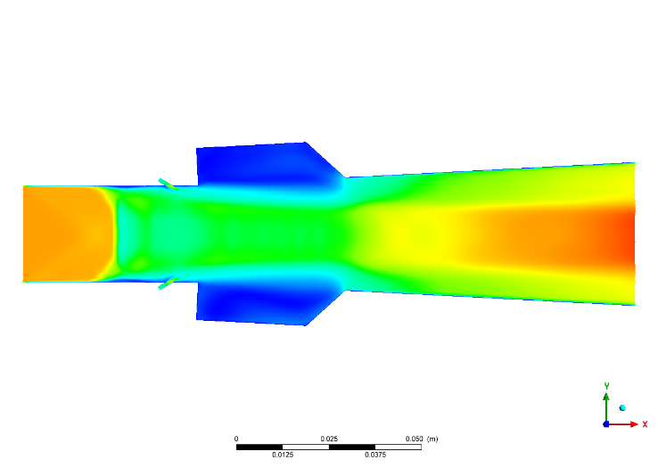

**b1)** (45,45)

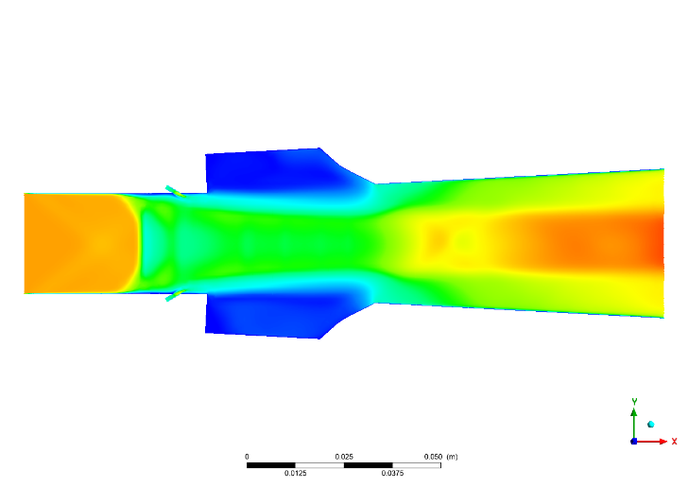

**b2)** (45,30)

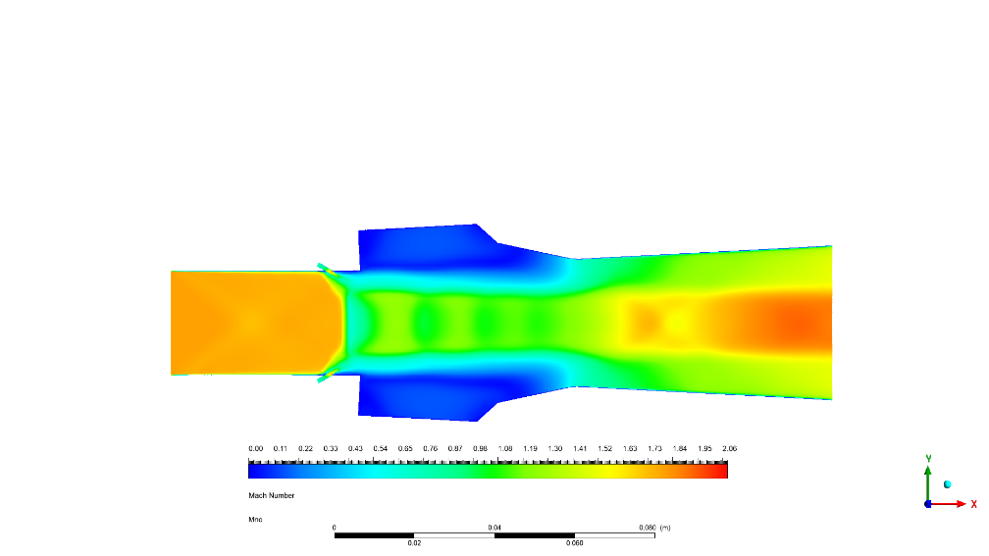

**b3)** (45,15)



**Fig 39.** Mach number contour comparison for different secondary ramp angles for a primary angle of 45°

Similar as before, the **case b3** where the flow is turned gradually at the secondary angle (15°) is seen to be more stable and favourable for combustion owing to the uniform deceleration afforded by the shock trains which also aid in better mixing and combustion. A relatively undisturbed upstream airflow is also noticed for the said case.

**Case c: primary ramp angle is fixed at 30**°

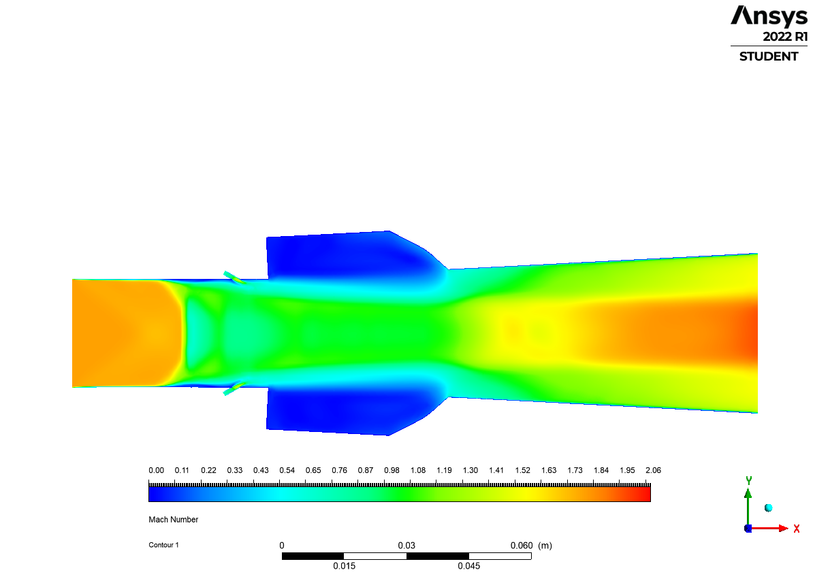

**c1)** (30,45)

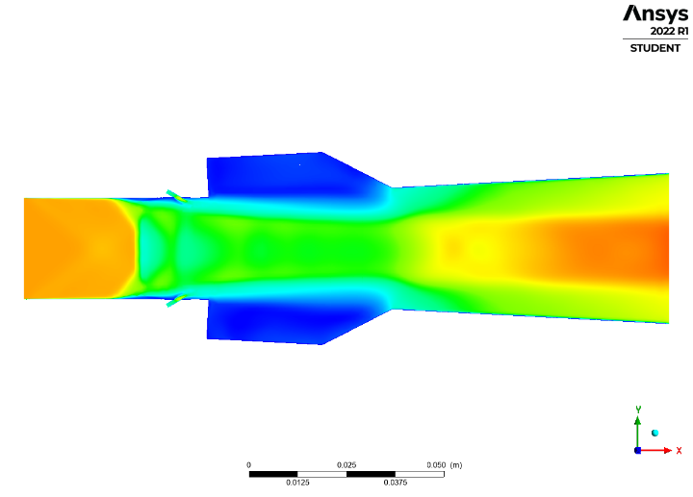

**c2)** (30,30)

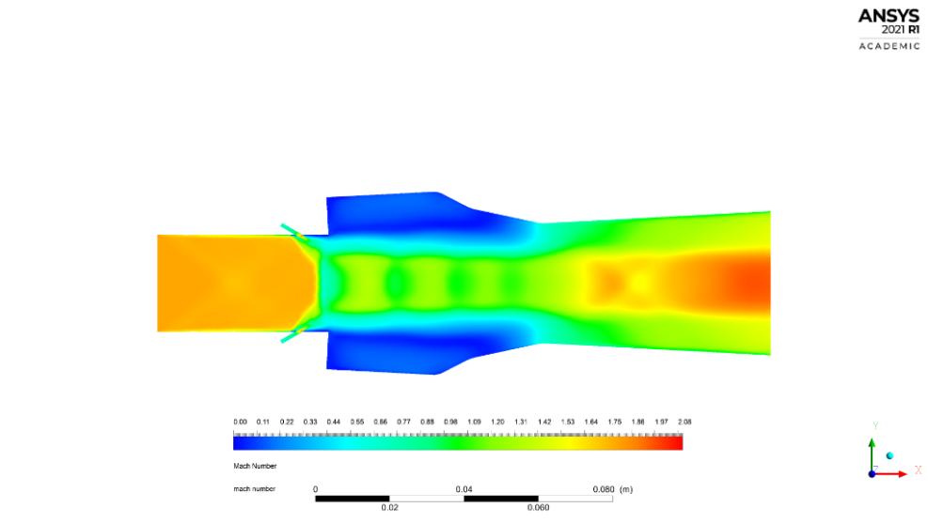

**c3)** (30,15)



**Fig 40.** Mach number contour comparison for different secondary ramp angles for a primary angle of 30°

A similar observation as before is noticed, **case c3** which has a more stable flow with a relatively undisturbed upstream flow owing to a less adverse back pressure due to combustion, as a result of the gradual turning of the flow by the secondary angle (15°), the stability of the flow as well as the deceleration shock pattern is superior to the other cases.

There is also the case of the low-speed region which extends all the way upto the end of the cavity section for all cases with 15° owing to its higher length due to the shallow angle the flow stays in slower speeds for longer further aiding the mixing and combustion.

From this analysis we can conclude that the secondary ramp angle of 15° is preferable and is hence selected.

On further investigation of the contours for evaluation of the primary ramp angle, (compare as case a1, b1 & c1; case a2, b2 & c2; case a3, b3 & c3)

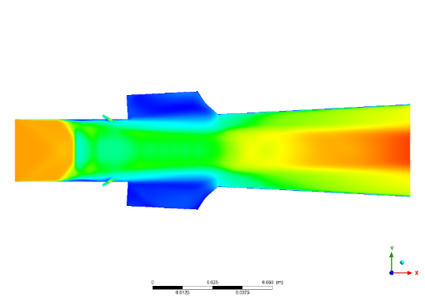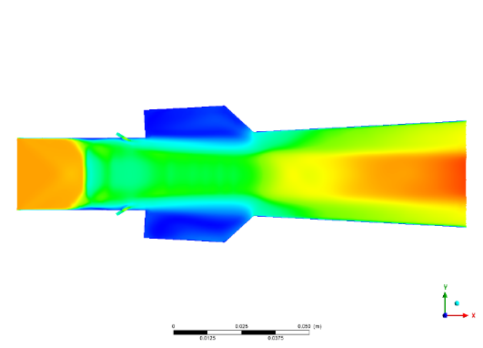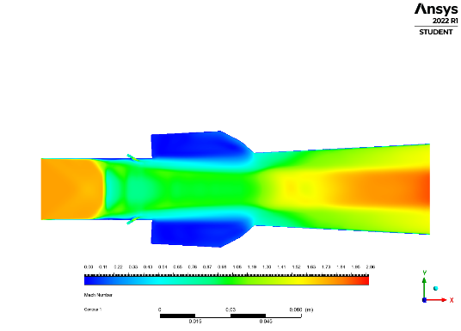

**case a1 (60,45) case b1 (45,45) case c1 (30,45)\***

**Fig 41.** Mach number contours for all cases with secondary ramp angle 45°

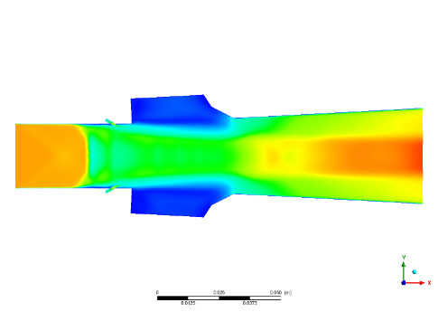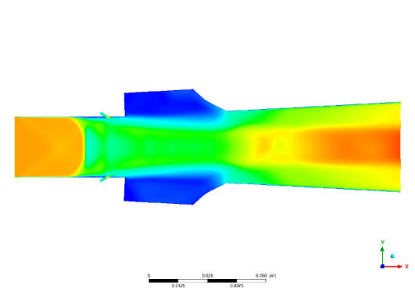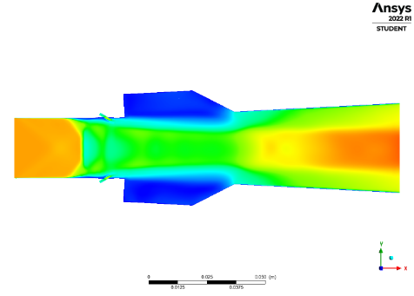

**case a2 (60,30) case b2 (45,30) case c2 (30,30)**

**Fig 42.** Mach number contours for all cases with secondary ramp angle 30°

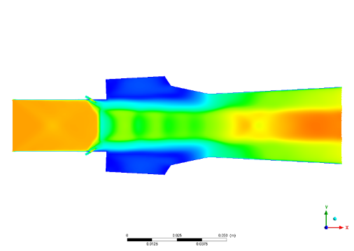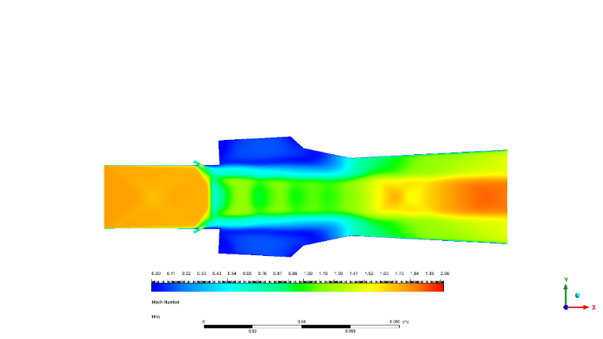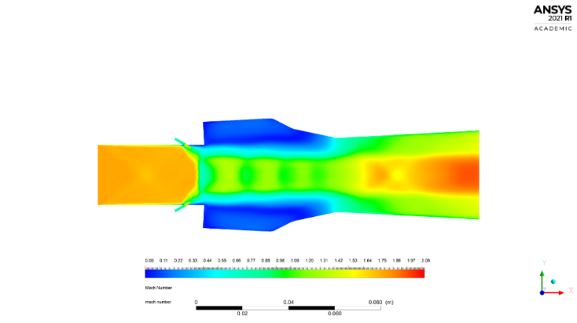

**case a3 (60,15) case b3 (45,15) case c3 (30,15)**

**Fig 43.** Mach number contours for all cases with secondary ramp angle 15°

From the comparison of the above contours there seems to be no significant change in properties. However, for the case of cavity with 30° primary cavity the length of the said cavity is higher (higher L/D values) and as a result slower speeds can be maintained for more of the length which could mean a better mixing and combustion, to ascertain this we have to analyse the comparative plots.

* The case c1 is special because it is the only case where the flow is turned inwards.

**4.3.2 Wall Static pressure distribution:**

**a)**

**b)**

**c)**

**Fig 44.**  Wall static pressure comparing the primary angle of the cavity **a)** 60o **b)** 45o & **c)** 30o.

From the above plots it can be ascertained that, cases with secondary ramp angle of 15o has the best combustion properties with less jumps and more sustained, giving a relatively stable combustion.

**a)**

**b)**

**c)**

**Fig 45.**  Wall static pressure comparing the secondary angle of the cavity **a)** 45o, **b)** 30 o, **c)** 15o

From the above plots it can be ascertained that, the cases where the primary ramp angle is 30 o, the pressure is sustained a bit longer for this angle for all cases of secondary ramp angles, and more pronounced for the angle combination of (30,15) ie. **case c3**. This confirms our hypothesis that the slower speeds can be maintained for more of the length (for 30 o primary angle) which gives a slightly better mixing and combustion. Hence due to the combustion staying on for a bit more of the length the pressure due to it is sustained for a bit longer.

We carry out one more analysis for combustion before finalizing the **case c3** (30,15) design.

**4.3.3 Temperature:**

**Case a:**

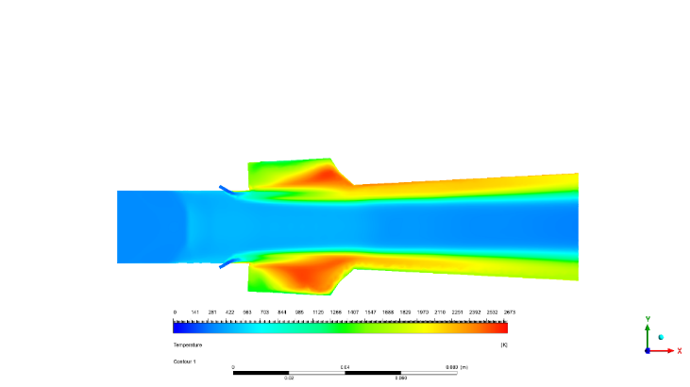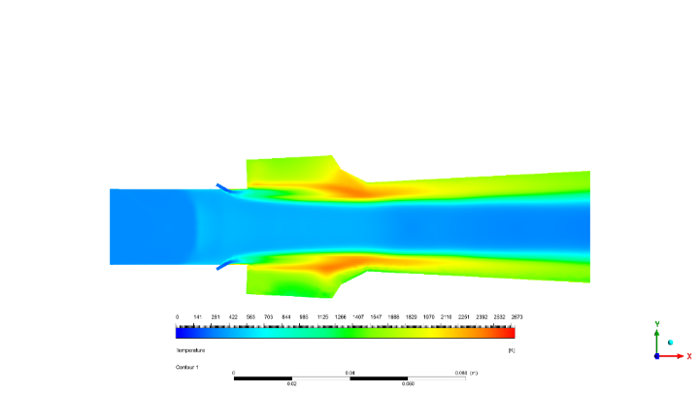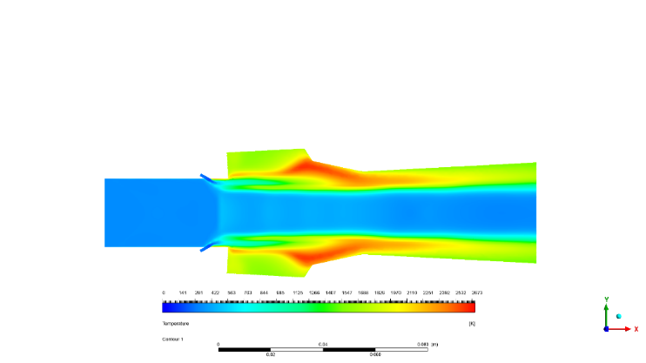

**a1)** (60,45) **a2)** (60,30) **a3)** (60,15)

**Case b:**

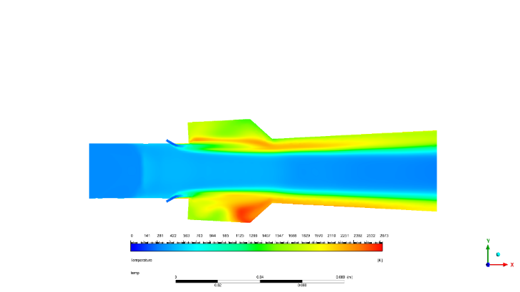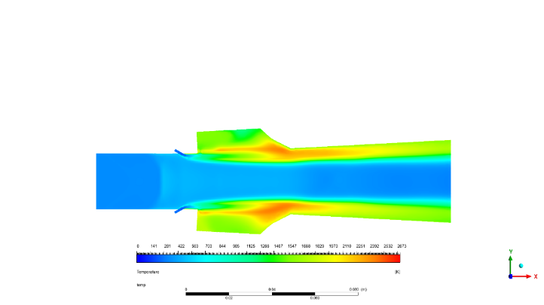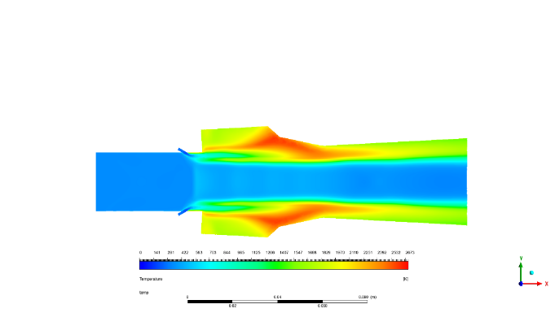

**b1)** (45,45) **b2)** (45,30) **b3)** (45,15)

**Case c:**

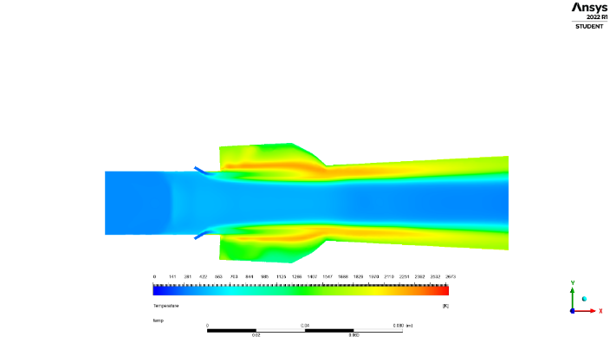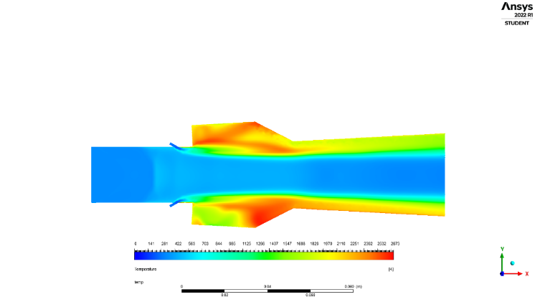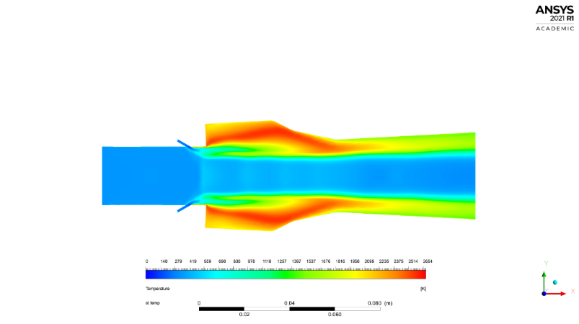

**c1)** (30,45) **c2)** (30,30) **c3)** (30,15)



**Fig 46.** Temperature contour comparison for varying aft ramp angles.

From the above contours it can be noted that when comparing the plots horizontally (secondary angle variation with primary angles fixed) that in all rows the 15o secondary ramp angle shows the most stable and complete combustion, with a larger area of combustion and higher temperature reached. This justifies our selection of the secondary ramp angle as 15o.

When comparing the plots vertically along the first column (primary angle variation with secondary angle fixed at 45o) we come to the conclusion that the primary angle of 30o is preferred as it has more stability however lesser combustion temperature and region of combustion, the other cases have unevenly distributed combustion, even though they reach higher temperatures and have larger areas of combustion they will affect the stability of the combustion.

This observation however reverses when comparing along the second column (primary angle variation with secondary angle fixed at 30o) without a secondary ramp angle (as both angles are 30o) the flow in the 30o primary angle case becomes unstable, this indicates the importance of the secondary angle. The flow is unstable with this case c2 and relatively more stable in the other cases, however a more complete combustion with a larger combustion region and higher temperature is observed.

The most important comparison is along the third column (primary angle variation with secondary angle fixed at 15o) as this is the angle which has been selected by us. Here is where the primary ramp angle of 30 o completely outclass the 45 o and 60 o models, having a significantly higher and uniformly distributed combustion area, reaching higher temperatures. This **(case c3)** is the final model which we will select.

The analysis of temperature has supported the case for the selection of the **case c3 (30,15)** model.

**CHAPTER 5**

**CONCLUSION:**

The flow property information was obtained for our axisymmetric scramjet combustor with various design setup arrangements by means of computational evaluation. All cases are modelled for an inlet Mach number of 1.8. The changes in the flow properties are visualized using the contours of Mach number, temperature, and the combustion is monitored using the contours of mass fractions of H2(fuel) and H2O (product of combustion). All contours are visualized in the longitudinal plane to indicate the change of parameters along the longitudinal span ie. direction of the flow. Comparative plots for wall static pressure and temperature (owing to most of the combustion occurring close to or just aft of the cavity) are also plotted to ascertain the performance and hence do the selection of the optimum geometry.

Our study results show the combustion performance changes with the variation in fuel injection position and angle coupled with the variation in ramp angles for the cavity geometry.

It is noticed that in case of injection angle, that the performance is better for fuel injector cases where the fuel is injected in a transverse manner to the airflow (90° & 45°) owing to better fuel penetration. And it is also noticed that in case of injector position, that the performance is better for fuel injectors positioned slightly upstream of the cavity and in a transverse manner (45°).

This is clearly noticed in the wall-static-pressure plots of case 4 (transverse 45° upstream injection).

It is noticed that in the case of the cavity’s double aft ramp angles, the primary angle that turns the flow inwards less abruptly (by 30° in our case) shows better combustion performance, *owing to the formation of preferable recirculation regions which provide better mixing and hence better combustion.*

This is somewhat noticed in the wall-static-pressure plots for all case c (primary ramp angle 30°).

For the case of the cavity’s second ramp angle, similar to the primary angle, the angle which turns the flow gradually (by 15° in our case) shows better combustion performance.

This is clearly noticed in wall-static-pressure plots for subdivision 3 for all the cases (secondary ramp angle 15°).

**CHAPTER 6**

**FUTURE SCOPE OF WORK**

Hypersonics is a stream in developmental stage, hypersonic flight is mostly accomplished by means of rocket engines, however these are expensive, complex, heavy and also run for shorter periods of time (low specific impulse). Scramjet for the most part is only an experimental concept and still has a long way to go and has great potential for further development. The use of scramjet concept for hypersonic propulsion would make hypersonic flights more affordable and longer, because we do away with the afore mentioned dependency on the inefficient rocket propulsion and along with it the mechanical nightmare that come with it. As scramjet is an air breathing engine and does not need to carry along the oxidizer and the accompanying apparatus, this makes the scramjet engine light, efficient and of simple operation.

Cavity based combustor designs have been proven effective and have been used, albeit in engines with a rectangular shaped duct cross section [4]. However for our case a new and radical axisymmetric, circular shaped duct cross section with cavity is used. Owing to the nascency of the design [2] there is a lot of experimental research to be undertaken especially in the field of combustion (using hydrogen as fuel), as a cold flow experimental has already been carried out for the various ramp angles concerning the cavity geometry [2].

Further modifications to the model may include introducing a centrally mounted strut to the design to investigate the coupled cavity-stut performance.

Designing a viable scramjet body around our model, (which is only the isolator section of the scramjet). A design with a suitable inlet compression zone, injection zone (isolator), combustion zone and a suitable expanded nozzle to gain maximum thrust, whilst keeping in mind the operating conditions.

**REFERENCES**

[1] Relangi, N., Ingenito, A., & Jeyakumar, S. (2021). The implication of injection locations in an axisymmetric cavity-based scramjet combustor. Energies, 14(9), 2626.

[2] Jeyakumar, S., Assis, S. M., & Jayaraman, K. (2017). Experimental study on the characteristics of axisymmetric cavity actuated supersonic flow. Proceedings of the Institution of Mechanical Engineers, Part G: Journal of Aerospace Engineering, 231(14), 2570-2577.

[3] Relangi, N., Garimella, D., Jayaraman, K., Venkatesan, J., Jeyakumar, S., & Ingenito, A. (2020). Computational Simulation of Axis Symmetric Aft Wall Angle Cavity in Supersonic Flow Field. In AIAA Propulsion and Energy 2020 Forum (p. 3712).

[4] Hsu, K. Y., Carter, C. D., Gruber, M. R., Barhorst, T., & Smith, S. (2010). Experimental study of cavity-strut combustion in supersonic flow. Journal of Propulsion and Power, 26(6), 1237-1246.

[5] Gruber, M. R., Baurle, R. A., Mathur, T., & Hsu, K. Y. (2001). Fundamental studies of cavity-based flameholder concepts for supersonic combustors. Journal of Propulsion and power, 17(1), 146-153.

[6] Ben-Yakar, A., & Hanson, R. K. (2001). Cavity flame-holders for ignition and flame stabilization in scramjets: an overview. Journal of propulsion and power, 17(4), 869-877.

[7] Zhang, X., & Edwards, J. A. (1990). An investigation of supersonic oscillatory cavity flows driven by thick shear layers. The Aeronautical Journal, 94(940), 355-364.

[8] Perng, S. W., & Dolling, D. (1996). Passive control of pressure oscillations in hypersonic cavity flow. In 34th Aerospace Sciences Meeting and Exhibit (p. 444).

[9] Zhang, X., Rona, A., & Edwards, J. A. (1998). The effect of trailing edge geometry on cavity flow oscillation driven by a supersonic shear layer. The aeronautical journal, 102(1013), 129-136.

[10] Iqbal, M. Z., & Chan, A. (2015, December). A study of the effect of element types on flow and turbulence characteristics around an isolated high-rise building. In Eleventh International Conference on CFD in the Minerals and Process Industries.

[11] Assis, S. M., Suppandipillai, J., & Kandasamy, J. (2021). Transverse Injection Experiments within an Axisymmetric Scramjet Combustor. International Journal of Turbo & Jet-Engines, 38(4), 489-495.

[12] Lakka, S., Randive, P., & Pandey, K. M. (2021). Implication of geometrical configuration of cavity on combustion performance in a strut-based scramjet combustor. Acta Astronautica, 178, 793-804.

[13] Suneetha, L., Randive, P., & Pandey, K. M. (2019). Numerical investigation on implication of dual cavity on combustion characteristics in strut-based scramjet combustor. International Journal of Hydrogen Energy, 44(60), 32080-32094.